# Table of Contents

# Table of Content

Table of Content 1

List of Figures 5

1. Introduction 6

1.1 Introduction 6

1.2 Background and Motivation 7

1.3 Problem in brief 7

1.4 Aim and Objectives 8

1.4.1 Aim 8

1.4.2 Objectives 8

1.5 Solution 8

1.6 Summary 9

2. Literature Review 10

2.1 Introduction 10

2.2 Similar approaches 10

2.2.1 Image Cloning 10

2.2.1.1 Segmentation Based Image Copy-Move Forgery Detection Scheme 11

2.2.1.2 Image Copy-Move Forgery Detection using Hierarchical Feature Point Matching 12

2.2.1.3 Adaptive Polar based Filtering method for Image Copy-Move Forgery Detection 13

2.2.2 Image Resampling 13

2.2.2.1 Construction of a database of synthetic maps for different resampling ratios 14

2.2.2.2 Resampling Detection with Linear Predictor Residue 15

2.2.3 Image Splicing 16

2.2.3.1 Splicing Detection using Inconsistencies in Motion Blur 16

2.2.3.2 Splicing Detection using Inconsistencies of Shadow Parameter 17

2.2.3.3 Splicing Detection using Discontinuities of Illumination Colour 18

2.2.4 Image Retouching with Filters 19

2.3 Summary 23

3. Technology Adapted 24

3.1 Introduction 24

3.2 Technologies Adapted 24

3.2.1 Programming Languages 24

3.2.2 Development Tools 24

3.2.3 OpenCV 24

3.2.4 Libsvm 24

3.2.5 Version Controlling Systems 25

3.3 Summary 25

4. Our Approach 26

4.1 Introduction 26

4.2 Image Cloning Detection Module 26

4.3 Image Resampling Detection Module 26

4.4 Image Splicing Detection Module 26

4.5 Image Retouching Detection Module 27

4.6 Summary 27

5. Analysis and Design 28

5.1 Introduction 28

5.2 High Level Architecture and Design 28

5.2.1 Image Cloning Detection Module 28

5.2.2 Image Resampling Detection Module 31

5.2.2.1 Find Correlated Pixels in Image 32

5.2.2.2 Apply Fourier Transformation 34

5.2.2.3 Classification of the Periodic Map Using SVM 34

5.2.3 Image Splicing Detection Module 36

5.2.3.1 Noise pattern Analysis 36

5.2.3.2 CFA interpolation Analysis 38

5.2.4 Image Retouching using filters Detection Module 39

5.4 Summary 45

6. Implementation 46

6.1 Introduction 46

6.2 Implementation 46

6.2.1 Image Cloning Detection Module 46

6.2.2 Image Resampling Detection Module 48

6.2.2.1 Generation of the periodicity map 48

6.2.2.2 Extracting features from the periodicity map and developing the Support Vector Machine for Classification 50

6.2.3 Image Splicing Detection Module 53

6.2.3.1 Noise Pattern Analysis 53

6.2.3.2 Colour Filter Array Interpolation Analysis 56

61

6.2.4 Image Retouching using Filters Detection Module 63

7. Evaluation and Results 76

7.1 Introduction 76

7.2 Evaluation and Results 76

7.2.1 Image Cloning Detection Module 76

7.2.2 Image Resampling Detection Module 76

7.2.3 Image Splicing Detection Module 77

7.2.3.1 Noise Pattern Analysis 77

7.2.3.2 CFA Interpolation Analysis 80

7.2.4 Image Retouching with Filters Detection Module 82

8. Conclusion and Further Work 84

8.1 Introduction 84

8.2 Conclusion and Further Work 84

References 86

List of Figures

# List of Figures

|  |  |  |
| --- | --- | --- |
| Figure 2.1 | General approach for the image cloning detection | 8 |
| Figure 2.2 | Methods for image segmentation | 8 |
| Figure 2.3 | The process flow | 14 |
| Figure 2.4 | Process flow of splicing detection through motion blur | 16 |
| Figure 2.5 | Process flow of splicing detection through shadow parameter | 17 |
| Figure 2.6 | Process flow of splicing detection through illumination color | 18 |
| Figure 2.7 | First order intensity difference | 21 |
| Figure 2.8 | Gaussian filtering detection diagram | 22 |
| Figure 5.1 | The basic structure of the design | 27 |
| Figure 5.2 | The architecture of the image cloning detection module | 30 |
| Figure 5.3 | Abstract Design of the image re-sampling detection module | 31 |
| Figure 5.4 | Re-sampling an image by a factor of 2/3; (a) original signal; (b) the up-sampled signal; (c) the interpolated signal [1] | 32 |
| Figure 5.5 | Steps of noise pattern analysis algorithm | 35 |
| Figure 5.6 | Image noise level definition | 36 |
| Figure 5.7 | Process flow of CFA pattern number estimation | 37 |
| Figure 5.8 | Process flow of CFA based noise analysis | 38 |
| Figure 5.9 | The process flow of image re-touching using filters detection module | 39 |
| Figure 5.10 | The complete detection of the image retouching using filters detection module | 40 |

Chapter 1

# 1. Introduction

## Introduction

The field of digital images has become a very trending and indeed a popular field among people no matter how age group they are in. Nowadays almost all the people from school kid to 70’s elder have smart phones and smart devices with them which enable them to capture images any moment. Therefore the use of digital images have shown a rapid development as well as a wide spread in society. With the growing usage of digital images, the reliability and the confidentiality of images have been questioned at a severe rate.

With the high rise of the usage of Digital Images, forgeries and tampering of mages have taken place. Many people digitally edit these images and use them illegally without owner authentication. Therefore Digital Image Forgeries have become a severe threat in modern society.

This system is developed with the main intention of protecting people from the damages that could be done with the tampering of digital images. Image forgery detection is to be carried out under different approaches for four forgery types. They are Image Cloning, Image Resampling, Image Splicing and Image retouching with filters. Above mentioned are the widely used tampering approaches that are currently taken place. Hence we intend to identify images that are digitally tampered under those categories. For that four separate modules are being developed with the use of novel algorithms. According to the feasibility by the time of the completion of the project, it is planned to carry out an evaluation based on different algorithms that are used in the development process.

The organization of the report is as follows.

Chapter 2 will state a literature review based on the project and a review of other’s work. Chapter 3 is about the technologies that are adapted in the implementation phase. Approach of the group towards the problem and its solution is briefly described in the fourth chapter. Chapter 5 will give an overview about the analysis and design of the system with the aid of necessary charts and diagrams. Chapter 6 contains the discussion of the project which gives a brief summary on the project.

## Background and Motivation

In the present world many people have the luxury of having digital cameras with them even on their routine works. Many people use smart phones equipped with digital cameras which lead to an era of digital images. Unfortunately this digital technology has begun to erode the trust and the confidence in the integrity of imagery. From the tabloid magazines to the fashion industry and in mainstream media outlets, scientific journals, political campaigns, courtrooms, and the photo hoaxes that land in e-mail in-boxes, doctored photographs are appearing with a growing frequency and sophistication. Therefore the field of Digital Forensics has emerged in uplifting and restoring the trust towards digital images.

## Problem in brief

In the present society, editing and tampering of a digital image has become much easier with the rapid development of digital image processing technologies and the popularity of the digital cameras. Even an inexperienced person can easily adopt to these technologies and perform image forgeries with the aid of user friendly software. Cloning, Splicing, Resampling, Image Splicing and use of filters to smoothen and sharpen an image have become the most common forgery types that could manipulate images in a way that is very hardly to perceive by naked human eye. Hence it is very important to detect these above mentioned image forgery types.

In addition digital images play a vital role in many different areas such as criminal and forensic investigation, military, journalism and etc. Therefore in order to avoid this critical situation, Image Forgery Detection system will be developed considering various aspects of Image Forgeries

## Aim and Objectives

### Aim

The aim of this project is to develop a system that detects Editing and tampering of digital images under four categories such that Cloning, Re-Sampling, Splicing and use of Smoothing and Sharpening Filters.

### Objectives

The objectives of this project are,

* Review and understand the literature that is published under Digital Image Forgery Detection.
* Develop fully functional modules to detect image forgery occurred with Image Cloning, Re-Sampling, Splicing and using Smoothing and Sharpening Filters.
* Finding the relevant datasets.
* Test Accuracy with the different approaches that are taken under same Image Forgery Type.

## Solution

Solution for the above identified problem is a Digital Image Forgery system which covers four main areas of Image Forgeries such as Image Cloning, Image Resampling, Image Splicing and Use of Filters. The modules are implemented with two different technology streams in an independent manner; Image Cloning and Use of Filters modules with OpenCV and python where the Image Splicing and Image Resampling modules are implemented with Matlab. With the assistance of researches done on related works, the most suitable novel solutions have been introduced for each module. The implementation process has gone through various experiments in order to find the most suitable solution avoiding pitfalls and gaps that exist in recent approaches.

Development of all four modules follow the following steps:

* Research on related work
* Experimental Implementation
* Finding relevant datasets
* Implementation
* Evaluation

## Summary

The chapter briefs about the research project with its aim and objectives. In addition it contains the background details of the project and what motivates us to select this area as the final year research project.

Chapter 2

# 2. Literature Review

## 2.1 Introduction

This chapter discusses about the similarities and differences of similar approaches that are taken to solve the exact same problem. In this chapter we mainly consider about comparing and contrasting the other’s work with the suggested approach highlighting its importance and uniqueness. Each section contains the review of other’s work related to separate modules as follows.

* Image Cloning
* Image Resampling
* Image Splicing
* Image Retouching with Filters

## 2.2 Similar approaches

### 2.2.1 Image Cloning

Basically the image cloning (copy move) forgery detection is done in two main approaches,

1. block based
2. key point based

The main issue with block based is the heavy computational intensity [6]. But on the other side of the scale we have the accuracy. Due to heavy searching through out the image the probability of getting the most correct place is high in block based approaches.

But the second approach of key point based copy move forgery detection is not that heavy computational as we only focus on the special blobs of the image. And bead on the feature descriptor we can build a robust cloning detector. For instance if we use feature descriptors like Scale Invariant Transform (SIFT), Speeded Up robust features (SURF) and DAISY then the areas of detection will be robust against geometrical transformations.

In a typical key point based cloning forgery detection following three main steps are abundant.

1. Feature Extraction
2. Feature Matching
3. Post-processing

Here post processing is mostly done to remove the false-true matches of the detected areas through feature matching.

#### 2.2.1.1 Segmentation Based Image Copy-Move Forgery Detection Scheme

[3] L. Jian et al. have developed forgery detection scheme based on the following flow chart,

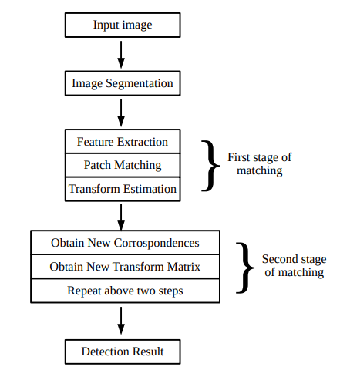

Figure 2.1: Flow Chart for the Image Forgery Detection Schema

Image segmentation → SLIC algorithm is used for image segmentation

Feature extraction → SIFT key points are extracted

Patch Matching → k nearest neighbors are searched for the features and measured similarity with a threshold of 0.04. And a patch is said to be matched with another only if both the patches have key points above some threshold.

Transform estimation → transformation matrix is calculated between two matched key points using RANSAC estimation method.

#### 2.2.1.2 Image Copy-Move Forgery Detection using Hierarchical Feature Point Matching

[2] Yuanman et al. In their approach too follows the typical three steps of forgery detection algorithm as mentioned above.

Feature extraction → high number of features are extracted by lowering the contrast threshold of SIFT features and by scaling up the image by a factor of 2.

Feature Matching → two problems arrived in matching features as the number of extracted features were increased.

1. The matching was reduced to 1 to 5 due to having the identified key points were slightly different and though they were at the same place they are found at two different scales.
2. The computational intensity of matching key points increased by O(n2).

These two problems were solved using the following strategy.

1. Group the key points based on some overlapping quantized gray levels before matching the key points.

Post processing → local affine homography estimation was developed using RANSAC algorithm for each matched key points. This obtained homography estimation ØH was compared with the dominant orientation of SIFT key points Øk. This give the equation,

(2.1)

f(k, k`,H) = |Øk` - Øk - ØH|

And it is declared as a forged image if there are 5 pairs of matched key points satisfy this function.

#### 2.2.1.3 Adaptive Polar based Filtering method for Image Copy-Move Forgery Detection

In [1] Xiuli et al., T=the main focus of this paper in detecting forgery is to do the operation with minimum computational intensity and identification of small forged areas very accurately.

The main steps of the technique in detection are,

SIFT key point extraction

Feature matching (knn)

Pixel classification into groups Symmetrical Matched Pixels (SMP) and Unsymmetrical Matched Pixels (UMP) based on the fact that whether the feature pixel (Pi,Pj) fall into matched pixel pairs in both ways of (Pi,Pj) and (Pj ,Pi)

Polar distribution is calculated using a navel equation for both the SMP and UMP separately.

Adaptive threshold is calculated separately for the SMP and UMP sets separately based on statistical manipulations.

Finally the forged area is confirmed and exact forged pixels are detected by using morphological operations.

### 2.2.2 Image Resampling

Image resampling is essential to give a consistent and natural appearance when a new image is created using splicing of other images. So every forged image have undergone geometric transformations such as scaling, rotation etc. which results in resampling of the images. Geometric transformations typically require a resampling. Due to this reason image resampling detection is an essential feature of image forgery detection. So many studies have been conducted on how to detect image resampling of images.

All the methods designed so far has a common underlying basis of detecting signal specific detectable statistical changes that occur due to the interpolation techniques. According to those studies resampling imposes periodic correlations between pixels do not exist in not resampled images. These correlations can estimated by a learning algorithm. In order to determine if the image has been resampled, the found correlations has to be passed to a classifier. Different studies have used different classifiers to detect the resampling of images [7].

#### 2.2.2.1 Construction of a database of synthetic maps for different resampling ratios

The approach mentioned in [8] was developed with the idea that interpolated samples show a linear combination with their neighboring pixels. The initial step of this approach is identifying the correlated neighboring pixels. The Estimation Maximization Algorithm was used to find the correlated pixels using resampling coefficients to estimate the probability map which is the output from the EM Algorithm.

Then Fourier Transformation was applied to enhance the peaks available in the probability map to make it easier to detect periodic correlations available. The main purpose of generating a synthetic map was to quantify the sensitivity and robustness of the EM Algorithm. Then the generated synthetic map was compared against the probability map and their difference is calculated. If this calculated difference exceeds the predefined threshold value that image was classified as a resampled image and if the difference is lesser than the threshold value that image was classified as a genuine image with no resampling artifacts.

Then a synthetic probability map which contains periodic patterns that are available in resampled images was created.

The main drawbacks in this approach is that it is only able to detect forgeries in uncompressed TIFF images, and JPEG and GIF images with minimal compression. So it can’t detect forgeries in recompressed JPEG images which occurs more frequently.

Figure 2.2: The Process Flow

#### 2.2.2.2 Resampling Detection with Linear Predictor Residue

In this approach discussed in [7] also exploits the method in [8] and proposes a faster resampling detection method than [8]. The basis of this approach is weighted least squares (WLS) estimation of the initially unknown scalar weight incorporated into an iterative expectation maximization (EM) framework [7]. To calculate the scalar weights required for the generation of the p-map they have used a fast linear filtering method with preset coefficients. Here also initially they have created a probability map which is a measure of the strength of linear dependency derived from the prediction error e, and it is modelled as a zero mean Gaussian random variable. The probability map was calculated using the following equation where λ, σ >0 and ґ ≥ 1, which is faster than the methodology used in [8].

(2.2)

$$p= λ\exp{(-\frac{{|e|}^{r}}{σ})}$$

Then Discrete Fourier Transformation is done to make the distinct peaks which are the characteristics that are used to detect the resampling visible. In this phase they have used an approach to automatically detect the peaks in a p-map’s spectrum.

Then they have used a cumulative period gram, which is used for time series analysis to detect the presence of particular frequency components. This equation was changed to calculate a 2D version from the first quadrant of a p-map’s DFT.

Then a new decision criteria was calculated using the maximum absolute gradient of the cumulative period gram. This value was compared with a Threshold value and if it exceeds that value it was classified as a resampled image.

But there are some ambiguities in identifying the characterized peaks generated by the probability map and it’s unable to identify the geometric distortion attacks against resampling detection.

### 2.2.3 Image Splicing

Image splicing is commonly known as developing a composite picture by adding a separate objects or regions from some other image. Splicing is one of the forgery types that are commonly used in modern society. Therefore many researches have been initiated on different approaches in order to detect Image Splicing. Following are the Identified approaches of Splicing Detection.

* Splicing Detection using Inconsistencies in Motion Blur [9].
* Splicing Detection using Inconsistencies of Shadow Parameter [10].
* Splicing Detection using Discontinuities of Illumination Colour [11].

#### 2.2.3.1 Splicing Detection using Inconsistencies in Motion Blur

This approach has been taken to detect Image Splicing using the discrepancies of motion blur estimations of the particular image [9]. Motion Blur refers to the relevant colour lines of a moving object that appears in a still image. Rather than that Motion Blur can occur due to the camera shakes.

In this approach, Motion Blur estimation has been used through image gradients in order to detect inconsistencies between the spliced region and the rest of the image. Complete absence of Motion blur is very helpful factor to detect Image Splicing. If the image does not have motion blur estimates though it was required, such incidents are said to be complete absence of Motion Blur, which lead to possible suspects of Image Forgery. Though the motion Blur was applied to a certain object in an image, there will be mismatches and inconsistencies. When compared to the original image.

When an image is given, its blur estimates are being calculated first. Then the image is being segmented using the previously calculated estimates. Different algorithms are used to calculate the Motion Blur Estimates. As it is mentioned in [9], a variant of the widely recognized cepstral method is used to estimate motion blur. Furthermore the study mentions that they have used spectral characteristics of the image gradients.

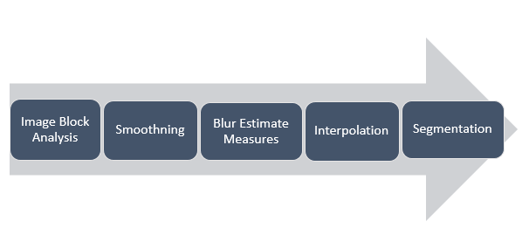

Figure 2.3: Process flow of Splicing Detection through Motion Blur

Though the approach is novel and high in accuracy, there exists some restrictions where the approach become unable in functioning. Since the detection is done through Motion Blur Estimates, this approach cannot be applied to images that do not contain motion blurs. Splicing in totally still images cannot be detected using this approach.

#### 2.2.3.2 Splicing Detection using Inconsistencies of Shadow Parameter

This is another novel method of detecting Image Splicing. Forgeries are detected by applying photometric constraints on shadows. Inconsistencies of Shadow parameter that occur due to the spliced object with the rest of the image are used in this approach.

As it is mentioned in [10], first they formulate the colour characteristics of shadows measured by shadow matte value. Shadow matte value (C) is a scale factor which is evaluated by analyzing illumination intensity in shadows [10]. The discrepancies of matte values of different shadows implies a possibility of a forgery.

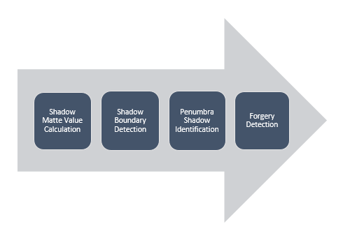

Figure 2.4: Process flow of Splicing Detection through Shadow Parameter

Even though this approach is used in Image Splicing detection, there are many restrictions and constraints that are needed to be concern when it comes to practical use.

Mainly this approach consider only about the photos that are taken outside considering that the only lighting source would be the sun. This method will not work properly in most of the cases where there are multiple lighting sources which cause multiple shadows for the same object. N such cases it would be very difficult to carry out the detection of Spliced Region. Next the researchers of [10] have made the assumption that the shadow receiving surface is always Lambertian. A Lambertian surface is a uniformly bright area from all directions of view where it reflects the same intense of light. In addition there is another restriction on the opacity of the object. The shadow generating object should be opaque and the distance between above object and the shadow receiving object should be non-trivial.

#### 2.2.3.3 Splicing Detection using Discontinuities of Illumination Colour

This is another novel method which uses a machine learning approach to detect Image Splicing with respect to the Illumination estimators of colours. In this approach, the differences of the illumination estimators of colours regarding similar objects are used in order to recognize splicing objects.

According to the [11] the initial step is to segment the image into homogeneous regions. Information from physics and statistical based illuminant estimators on image regions or similar material will be incorporated [11]. An illuminant map will be created by applying the extracted colour to the each region. Once a human expert sets bounding boxes around each faces, those will be cropped and their texture based and gradient based Illumination Map values will be computed. According to the number of faces in the image, Joint Vectors will be constructed. As the final step which is being done for the classification purpose, a machine learning based approach has been used in this method. If at least one pair of faces in the image is classified as inconsistently illuminated, then the image is categorized as a spliced image [11].

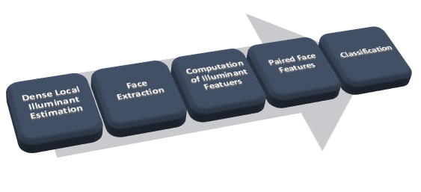

Figure 2.5: Process flow of Splicing Detection through Illumination colour

The main disadvantage of this method is that the approach is only restricted to images which have more than 2 or more faces. The approach mainly uses an automated skin comparison to check whether the image is spliced. Hence the method cannot be universally applied. In addition this approach requires human expertise to some extent which can be often misleading. So relying on human visual assessment helps to drop the accuracy of the method.

### 2.2.4 Image Retouching with Filters

Filtering is a technique which is utilized to enhance a picture. For a case you can utilize a particular channel to accentuate certain highlights. Some of the time it is utilized to expel a few highlights. In the picture preparing there are numerous channels utilized for improving the nature of the picture. Additionally when it is thinking about the picture falsification recognition, it ought to be viewed as the way that particular picture had connected particular channel for improving the picture or some time utilizing a channel it can be conceal the imitation territory. Ex: When it is thinking about a duplicate move falsification there are substitution of particular territory of the first picture. In the wake of duplicating the picture it ought to be smoothed the edges of recently included square of the picture. Those errands are done with utilization of the picture Filters.

Picture channel is an area task, which the estimation of any pixel in the yield picture is controlled by applying some calculation to the estimations of the neighboring pixels of the comparing input picture. In picture preparing there are chiefly two kinds of channels.

* Linear Filtering - Gaussian, Laplacian, Average and unsharp
* Non-Linear Filtering - Median

In this project it is expected to implement the detection the forgeries using above mentioned linear and non-linear filters

As indicated by the circumstance it is chosen the sort of filter. More often than not filters are utilized as a post handling activity in picture improvement. In a few times filtering is connected to shroud alternate tasks done in the first picture. Utilizing a filter it can be shroud the other sort of forgeries happened to the first picture like copy move, re-sampling. In here it ought to be viewed as what sort of filter ought to be connected and what are the strategy ought to take after for identifying the kind of channel which is connected to the first picture. There are number of ways to deal with distinguish the filter compose. In any case, it ought to be considered what the kind of identification strategy ought to be connected to identify the comparing filter. Some of the time it might be a linear filtering detection strategy. At times it will be a nonlinear filtering discovery strategy. There are a few ways to deal with identify the non-linear filtering. In any case, when it is thinking about the linear filters, there are few number of identifying techniques.

**Methods for detect the median filter. (Non-linear filter)**

**Enhanced Statistical Approach for median filter detection using difference image**

Unlike other approaches it is difficult to detect the non-linear filtering because of the non-linear characteristics of median-filtering. According to the [12] it is suggested a method for detecting the median filter using Local Expectation Features (LEF). In this approach utilize adjacent pixels of different image corresponding to input as well as median filtering (MF) version of input image for extracting proposed LEFs.

In this approach, it is considered the fact that no common analytical property between inputs and outputs because of the non-linearity nature of the median filter. Even though after applying the median filter, leaves some statistical characteristics. It is used these statistical characteristics to detect the median filter. In[13] authors used the probability of observing zeros in first difference image, as the identifying factor for separating median filter from other filtering operations. But the issue with this method is that give good accuracy only for UN-compressed median filtered images, the performance is deteriorated when using the JPEG compressed images. Here use a feature vector for detect the MF. It is consider the ratio h0/h1. Here h0 is the number of zeros and H1 is the number of 1s in the first difference image. Here it is degraded the performance when using JPEG compressed images. There author [14] use a Subtractive Pixel Adjacency Matrix features (SPAM) as a distinguishing measure for the MF images. Authors in [15] considered the characteristics of first and second order difference domain images to Obtain Global Characteristics Features (GCF) and Local Characteristics Feature (LCF), then joined these two vectors for get Global-Local Features (GLF) as a 56-D vector. This GLF has superior detection accuracy than others.

LEF – Local Extraction Features

This feature set is constructed from the expectation of probability maps obtained from image intensity difference values.

In blind detection of image forgery, the feature that output is a subset of input samples is used to detection of median filter. To overcome the issue of false alarm rates, only textured regions of an image are used for feature extraction. Binary mask is used to detect textured regions. For each pixel in the test image I with intensity value denoted by I (i,j) variance in local neighborhood of a pixel is calculated according to below equation.

(2.12)

(2.11)

(2.3)

$$σ \left(i,j\right)=Var \{I(m,n)\}$$

$$m ∈\{i-3, i+3\} \\ n ∈\{i-3, i+3\}$$

The binary mask M (i, j) is then produced from σ (i, j),

Based on variance threshold (σ τ ).

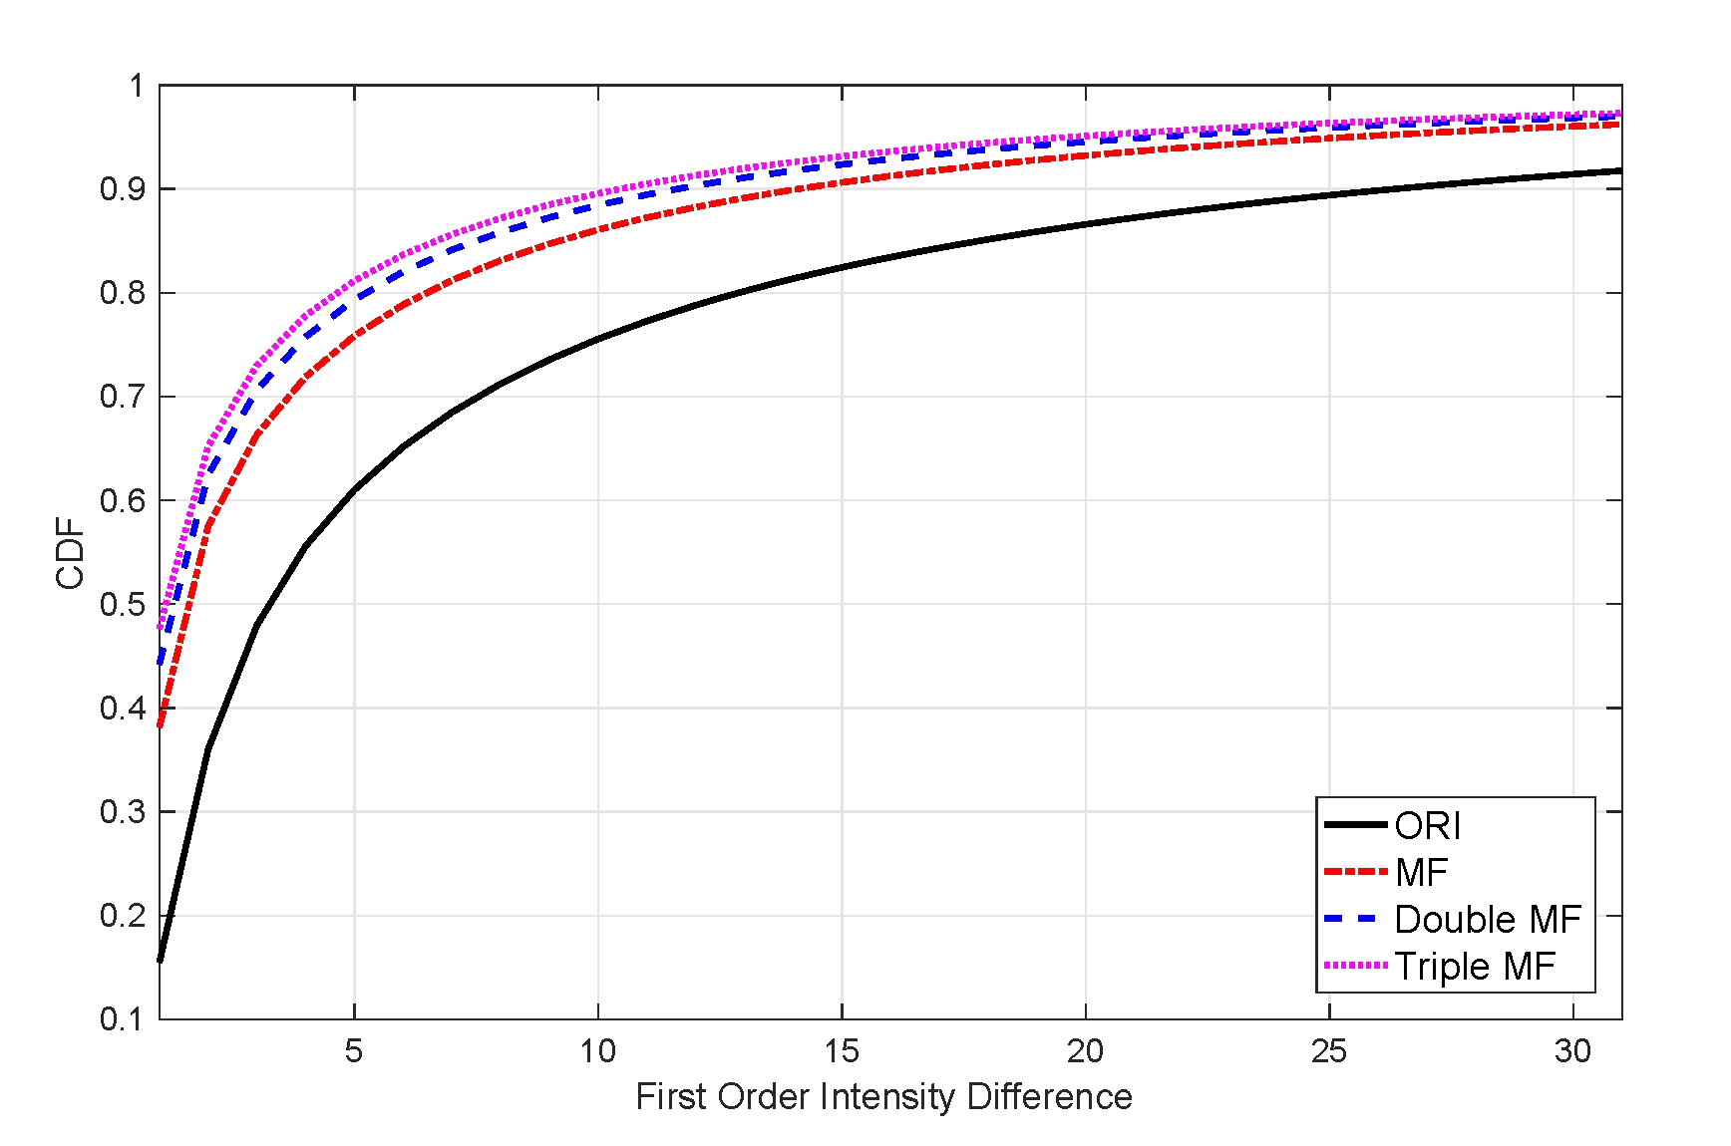

Figure 2.6: First Order Intensity Difference

Once the original image is median filtered, corresponding difference image will have more number of zeros, but increase in zeros or upward shift in cumulative histograms of consecutive MF images is not linear. This quality is used to detect the median filtered image.

In addition to this method there are many methods for median filtering detection. Convolution Neural Network, Local Ternary Pattern approach which fits to linear autoregressive model.

**Linear Filter Detection**

Detection of Gaussian Filter.

In the section of Gaussian Filter detection it is required to present three kinds of feature vector which are extracted from the edge ratios and parameters of Hough peaks .In the proposed algorithm[16], the formed a 10-dimensional feature vector and then trained using a support vector machine(SVM).

In here features are classified into two categories as spectral features and spatial features. J. Xu et al. [16] developed a method for detection of Gaussian low-pass filtering in the spectral domain. Authors used the frequency residual function that is used for detection of Gaussian low-pass filter in spectral domain. In here use the observation that frequency residual function of Gaussian filtered image presents a band-pass filter and original image presents a high-pass shape.

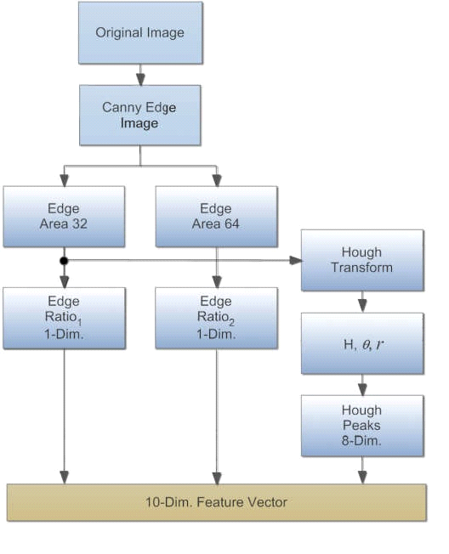

Figure 2.7: Gaussian Filtering Detection Diagram

## 2.3 Summary

Chapter two contained facts about similar approaches carried out by different people worldwide to solve the same kind of problem. It summarizes the other recent approaches that are taken to develop Digital Image Forgery Detection systems with respect to Image Cloning, Image Resampling, Image Splicing and Image Retouching with Filters. Chapter 3 will focus on the technologies used by the team to develop the system.

Chapter 3

# 3. Technology Adapted

## 3.1 Introduction

In this chapter the basic technologies we are going to use for the development process of different modules of our project are briefly discussed. We selected the technologies discussed below after analyzing the available technologies in terms of their appropriateness for our project. Accordingly we found that following are the most suitable technologies for our system. It also describes why we selected those technologies instead of other available technologies.

## 3.2 Technologies Adapted

### 3.2.1 Programming Languages

The programming language we are going to use for the development of our system is Python and Matlab. The main reasons for selecting Python is because it is a high level programming language which supports both object oriented programming, functional programming and there’s a high level of library support. Scikit Library was used along with python for Image Cloning Detection Implementation.

Matlab is multi-paradigm numerical environment which is a programming language which allows mathematical functions such as matrix manipulations, function plotting etc. [17]. The main reasons why Matlab was selected is the availability of many libraries, ability to interface with programs written in other programming languages such as C++, Python etc.

### 3.2.2 Development Tools

PyCharm and Matlab IDE will be used as the primary IDEs for our project. Visual Studio will also be used upon the necessity for developing the system.

### 3.2.3 OpenCV

OpenCV which is a library of programming functions which supports computer vision is the main library we are going to use for this project. The main reason for selecting it is the availability of a large no. of library functions and simplicity in the use.

### 3.2.4 Libsvm

LIBSVM is a library for Support Vector Machines (SVMs).Here we use the libsvm classification for image forgery detection of filters. The goal of using libsvm is easily do the classification on extracted image features. LIBSVM has gained wide popularity in machine learning and many other areas. Here we use for image classification.

### 3.2.5 Version Controlling Systems

Git is used as the version controlling system and the code repository in the development of the system**.**

## 3.3 Summary

The stack of technologies we are going to use mainly in our project is described in this chapter. In addition to these we are going to utilize some more tools and libraries in the development process of our system.

Chapter 4

# 4. Our Approach

## 4.1 Introduction

This chapter summarizes the approach followed by us to solve the identified problem of image forgery detection. The approach is explained in abstract level in terms of input, output and process of each modules.

## 4.2 Image Cloning Detection Module

This is implemented as another possible approach to detect copy move and the forged area. This is done based on the assumption that the forged area is to give some semantic meaning to the image (this means that the image is forged so that it is taking more than 10x10 pixel area).

Initially image is segmented using SLIC algorithm and SIFT features are identified. These identified SIFT key points are grouped according to the pre-identified segments and matching process is done between these pixels. If match with less error than the threshold is detected that patch containing the particular feature is named as forged. In case the forged area is not found then the most closest feature pair is considered and Histogram of Oriented Gradients (HOG ) features are extracted from the patches that reported to be the most closest in the suspect the area may have been really smoothed and there are issues in getting rich blob features (SIFT features in this case).

The main issue arrived in this case was the matching between the features of SIFT that has high

## 4.3 Image Resampling Detection Module

The input of this module is an image. Then image resampling detection algorithms such as EM algorithm is applied to find correlated pixels, Fourier Transformation is applied to enhance the peaks a SVM is used to classify the images as resampled or not resampled. The output of this module is the detection result that whether an image is forged by using image resampling or it’s a genuine image with no forgeries due to image resampling.

## 4.4 Image Splicing Detection Module

The input of this module is a tampered image. Then Image Splicing detection is done using Noise pattern Analysis, CFA (color filter array) interpolation and Analysis in this module. Here we are going to use algorithms such as Wavelet Transformation, Noise Level Estimation etc. and some customized algorithms. This module produces a detection result which indicates whether the input image is forged by using image splicing or it’s a genuine image with no forgeries due to image splicing.

## 4.5 Image Retouching Detection Module

This module also accepts an image as the input. In this module image forgeries due to sharpening and smoothing caused by both Linear Filters such as Gaussian, Laplacian, Average, Mean filters etc. and Non-linear Filters such as Median Filter are detected. The output of this module is the detection result that determines whether an image is forged due to sharpening or unsharpening or it’s a genuine image with no forgeries due to image retouching with filters.

In here we build quantization noise model and image model which is specially build to detect filtering forgeries to extract compression noise then this extracted compression noise is modeled as first order spatial ergodic Markov chain which has been effective feature to do the classification. Then Libsvm is used to do the classification. Here we used NCID and UCID and Dresden Image Data Set (Raw Images).

## 4.6 Summary

This chapter describes the abstract level architecture of our proposed system in terms of their input, process and output. This summarizes how each module functions and assists in achieving its objectives to achieve the final goal of the system.

Chapter 5

# 5. Analysis and Design

## 5.1 Introduction

This chapter describes about the structure of the design of our approach which is followed to address the problem identified. It consists the high level architecture of each component with block diagrams. The flow of each algorithm is briefly mentioned under separate topics.

## 5.2 High Level Architecture and Design

The approach consist of four separate modules developed to detect Image Splicing, Image Resampling, Image Splicing and Image Retouching with Filters. The modules are not connected to each other and they are to function individually.

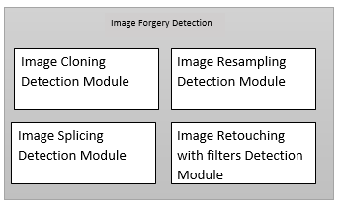

*Fig 5.1: The Basic Structure of the Design*

### 5.2.1 Image Cloning Detection Module

Image cloning is known as copying a part of image in to the same image into a different location may be with some geometric alteration and some other manipulations.

The basic structure of the implementation is as follows,

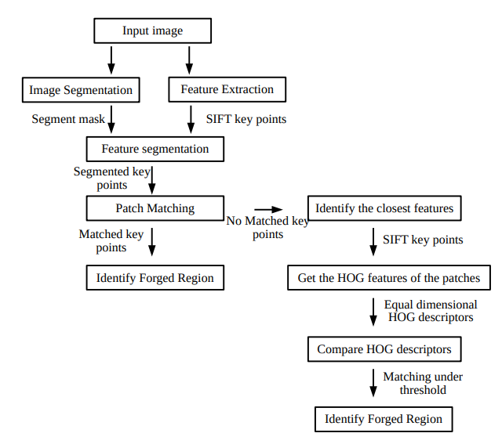

Figure 5.2: Process flow of the design

Image segmentation → Image need to be segmented to individual non interlacing patches in order to identify the forged region. That is if a forge is proved to be in a particular image then it will be one of these patches. SLIC algorithm is adopted to make this segmentation that use a super pixel based image segmentation approach and k-nearest neighbor algorithm to expand the area. This will generate a segmentation mask of the image. Hence this algorithm will cluster the similar pixels together within a closed area.

The segmentation is done at an upper bound of 500 units and a particular segmented image would appear as shown below. For this “skimage “image processing library is used.

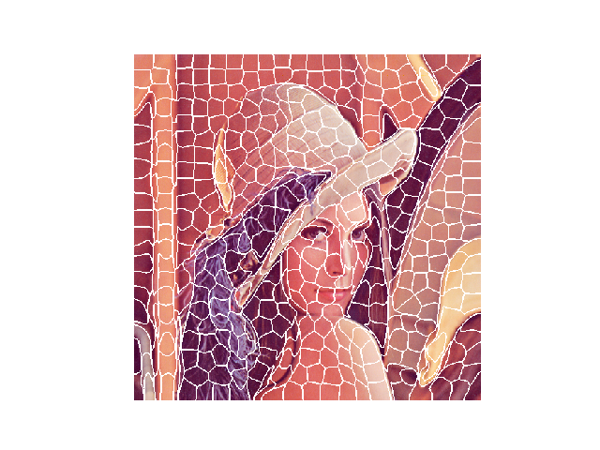Figure 5.3: Segmented Image

Feature Extraction → at the same time we can do the image feature extraction, where we use SIFT key points as the features. For the features description SIFT was used as the key points are proved to be robust against geometrical changes. So that the interested areas of forgery that might have been undergone geometrical changes will also be detected.

Feature Segmentation → above identified SIFT key points are grouped based on the mask obtained from SLIC algorithm. With this classification we can reduce the searching overhead to a great level.

Patch Matching → the classified key points are matched between the different patches that were obtained using a threshold of 50. Then if a particular patch is comprising of a match of more than 2 key point values than both those patches are considered to be forged. This patch matching is done until the end of each iteration without stopping at a particular match, which enable to identify multiple copy pasted areas.

A sample result of the clone detected image is shown as below through patch matching. Here the cloning was done using the clone tool of the GIMP editing software.

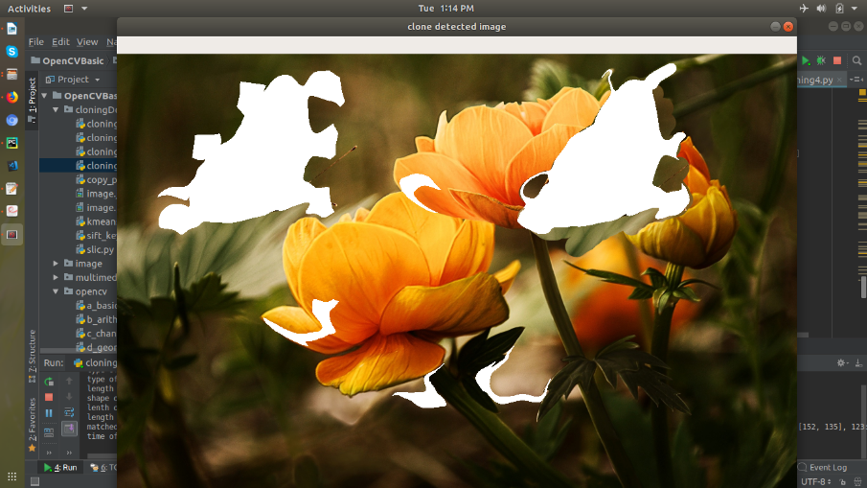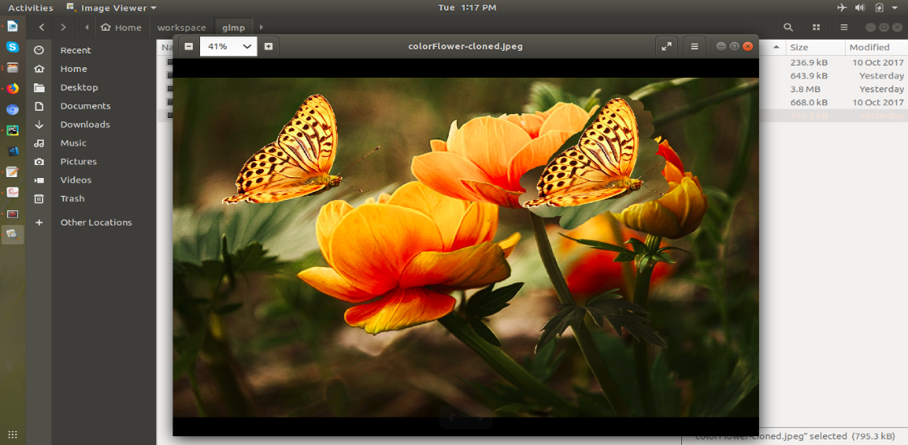

Figure 5.4: Cloned Image (left) and the Clone detected Image (right)

### 5.2.2 Image Resampling Detection Module

The abstract design of the Image Resampling Module can be shown as follows.

Figure 5.5 : The Abstract design of the Image Resampling Detection Module

#### 5.2.2.1 Find Correlated Pixels in Image

Resampling introduces periodic correlations between neighboring pixels which are not available in an original image. So the initial step of the Resampling Detection Module is to detect whether any linear correlations are available in the input image. To identify these correlated pixels in the input image following steps have to be followed.

The input image is a discrete signal and any discrete signal can be resized by a factor of p/q to n samples using the following there steps. They are,

1. Up-sample : create a new signal xu[t] with pm samples, where xu[pt] = x[t], t = 1,2, ……., m, and xu[t] = 0 otherwise, Fig. 1(b).
2. Interpolate : convolve xu[t] with a low-pass filter: xi[t] = xu[t] *h[t], Fig. 1(c).
3. Down-sample: create a new signal xd[t] with n samples, where xd[t] = xi[qt], t =1, 2, …,n. Denote the re-sampled signal as y[t] = xd[t], Fig. 1(d).

For interpolation process different types of algorithms such as Nearest Neighbor, Bilinear, Bicubic, Bicubic Smoother, Bicubic Sharper can be used.

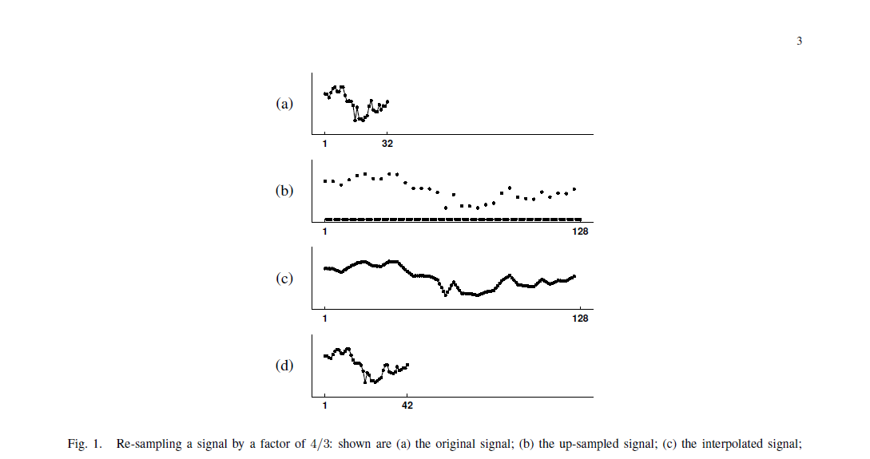

Figure.5.6. Re-sampling a signal by a factor of 2/3; (a) the original signal; (b) the up-sampled signal; (c) the interpolated signal [8]

Since all three steps in the re-sampling of a signal are linear, this process can be described with a single linear equation. Depending on the re-sampling rate, the re-sampling process will introduce correlations of varying degrees between neighboring samples.

For each pixel, its neighbors are the all pixels within a window of length 2N + 1. If a signal is resampled by an arbitrary factor of p/q it is necessary to determine αk which is the set of weights across the neighborhood.

(5.1)

$$y_{i}=\sum_{k=-N}^{N}{α_{k}}y_{i+k}$$

This can be written as αk is the set of weights across the neighborhood. Let ai be the *i* th row of the resampling matrix A p/q.

$$\vec{α_{i}}=\sum_{k=-N}^{N}{α_{k}}\vec{α_{i+k}}$$

(5.2)

A resampled pixel i is correlated with its neighbors whenever its corresponding row of the resampling matrix αi can be written as a linear combination of its neighboring rows [8]. This will result in periodic correlations between resampled pixels since the resampling matrix is periodic.

Then Expectation-Maximization Algorithm is used to determine the set of periodic samples that are correlated to their neighbors and the specific type of correlation between them.

At the initial stage it’s assumed that each sample belongs to one of the two samples M1 or M2. M1 represents the samples that are correlated to their neighbors and M2 corresponds to the samples which are not correlated (outlier model).

The EM algorithm is a two-step iterative algorithm. In the Estimation step (E-Step) the probability that each sample belongs to each model is estimated and in the Maximization step (M-Step) the specific form of the correlations between samples is estimated.

In the E-Step Bayes’ Rule is used to calculate the probability of each sample (*yi* ) belonging to model M1.

(5.3)

$$\operatorname{Pr}\left\{y_{i}∈M_{1}\right|y_{i}\}= \frac{\operatorname{Pr}\left\{y_{i }\right|y_{i}∈M_{1}\}}{\sum_{k=1}^{2}{\operatorname{Pr}\left\{y_{i} \right|y_{i} ∈ M_{k}\} \operatorname{Pr}\left\{y_{i }\right|y_{i}∈M_{k}\}⁡ }}$$

The output of the EM algorithm is a set of coefficients α and a probability map P.

Then the periodicity between the correlations are found using the Fourier Transform of the probability map. Here a peak detection algorithm has to be developed to enhance the peaks and suppress any correlations that occur due to the statistics of the original image.

#### 5.2.2.2 Apply Fourier Transformation

The Fourier transformation of the probability map $P\left(ωx,ωy\right)=F\left(x,y\right).W\left(x,y\right)$ takes the form of,

(5.4)

$$f\left(r\right)= \left\{\begin{aligned}1 0≤r<\frac{3}{4} \\ \frac{ 1}{2}+\frac{1}{2}cos⁡\left({π(r-\frac{3}{4}) \atop \sqrt{2}-3/4}\right) \frac{3}{4} ≤r ≤√2 \end{aligned}\right.$$

Then the Fourier transformed probability map is then sent to a high-pass filter to remove undesired low frequency noise. Once the undesired low frequencies are removed, the high passed spectrum is normalized and gamma corrected in order to enhance frequency peaks then rescaled back to its original range. Then the synthetic map is also Fourier transformed. Finally the similarity between the probability map and synthetic map is calculated.

#### 5.2.2.3 Classification of the Periodic Map Using SVM

We are going to use a SVM based classifier to classify the resampled images and not resampled images into two different classes based on the differentiation between natural peaks in an image and introduced peaks in the process of resampling. The periodic map generated in the previous map is used to extract the features required to differentiate between natural peaks in an image and introduced peaks in the process of resampling.

In the development of the SVM there are two steps as training the model and testing the module. For training the model we are going to use two groups of jpeg images which contains a balance amount of resampled images and non–resampled images. These resampled images are resampled using various methods such as resizing, rotation etc.

The following five features are extracted from the periodicity map.

1. The four largest coefficients

Here we are going to get the summation of the highest four coefficients of the respective periodicity map of an image because higher peaks indicate resampling.

(5.5)

$$f_{1} = \sum_{i=1}^{n}{\sqrt[m]{{|c}_{i}}}|$$

1. The four largest coefficients generated by peak detection using Fast Fourier Transform

The summation of the four largest coefficients resulted from the applying of the Fast Fourier Transform was taken as a feature.

(5.6)

$$f_{2} = \sum_{i=1}^{n}{\sqrt[m]{{|c }_{i}^{`}|}}$$

1. The four largest coefficient distance from center

As the natural peaks of an image have less frequencies, the four coefficients with highest frequencies are extracted and summed up.

(5.7)

$$f_{3} = \sum_{i=1}^{n}{\sqrt{u_{i }^{2}+ v_{i}^{2}}}$$

1. The four largest coefficient to local energy ratio

This feature is extracted by considering a local rectangular window of width *W* and getting the respective ratio for that particular window and then getting the aggregation.

(5.8)

$$f_{4} = {\left(\sum_{i=1}^{n}{100 r_{i}}\right)}^{m} ∕100$$

1. Peak to total energy ratio

Here the ratio between the total energy of the image and peak is considered as a feature.

$$f_{5} = {\left({10}^{4} R\right)}^{m} ∕100$$

(5.9)

Once these features are extracted, they are used as the inputs for the SVM Model. First the model is trained using the training set and then the testing set of images is used to verify the results. Then the trained model is capable of classifying a given image as resampled or not based on these features.

### 5.2.3 Image Splicing Detection Module

Passive splicing detection of an image is being addressed with the three following approaches.

* + Noise pattern Analysis
  + CFA (color filter array) interpolation Analysis

#### 5.2.3.1 Noise pattern Analysis

In this approach the image is being segmented into similar like sections with accordance to the noise the image generates when it is being produced. The given image may include different level of noises in different regions. The task is to detect such regions and locate them in order to identify the spliced area of the image. To achieve this the following algorithm has been designed.

Figure 5.7: Steps of Noise Pattern Analysis Algorithm

As the initial step, the image noise level is defined as follows where *fn (x,y)* is the Image Noise level, *f(x,y)* is the Uncorrupted Signal and *n(x,y)* is the noise.

(5.10)

$f_{n}\left(x,y\right)=f\left(x,y\right)+n(x,y)$

Figure 5.8: Image Noise level definition

Next, the image is converted into YCbCr model for further processing. For testing purposes the same implementation has been done with gray images. Once the image is converted into YCbCr model, its Y channel is being separated. Single level 2 dimensional wavelet transform is performed on the Y channel as the first step of the algorithm. For this Daubechies’ external phase wavelet with 8 vanishing moments is used. As a result of the transformation, we receive a matrix with four coefficients. Hereafter we use Detail coefficient matrix diagonal for the further implementations. As the next step, the image is constructed in to non-overlapping blocks where these blocks are assumed to be smaller the size of the spliced sections where to be localized. For this segmenting process the HH1 sub-band which gives the diagonal details of the image with the highest resolution and the total number of blocks are determined by the following equation where the image is of *(M * N)* pixels, *R* is the block size and *Bt*is the total number of non-overlapping blocks

(5.11)

$$B_{t}=\frac{M}{R}*\frac{N}{R}$$

As the proceeding step, the noise value of each segment will be estimated using wavelet-based noise estimation. Here we also calculate the standard deviation of noise. With that, homogeneous sub regions are classified based on the noise standard deviation condition. As the final step, region merging will be done comparing regions that have similar noise standard deviation values. As the final output, a map which includes regions with similar standard deviation of noise will be produced.

#### 5.2.3.2 CFA interpolation Analysis

Splicing can disturb the CFA which is known as Colour Filter Array, interpolation in ways which the splices are rescaled filtered where it disrupts the inter-relations between the pixels. In general two cameras do not use the same CFA array or interpolation algorithms which makes the mixing of two separate images taken from different cameras can be detected and localized with the analysis of these parameters. Therefore the basic idea underneath this approach is the significant alteration of CFA demosaicing artifacts caused by the image splicing operation. The alterations could be either lack of artifacts or detection of weak artifacts.

Once a tampered image is given, its green channel is extracted first. The green channel is chosen out of Red and Blue channels, because it is always up sampled by a factor of two. The Interpolated and Acquired samples are known as lattices. The implementation is based on the assumption that variance of prediction error in Acquired Lattice is always higher than the variance of prediction error in Interpolated Lattice. When there is no demosaicing in the image, it is assumed that there is no difference between variance values between Interpolated Lattice and the Acquired Lattice. Before this comparison, the prediction error for both lattices should be calculated.

Let’s consider the observed image as *s(x, y)* where *x, y* could be any Integer. The prediction error *e(x, y)*, could be defined as follows.

(5.12)

$$e\left(x,y\right)=s(x,y)-\sum_{μ,υ≠0}^{∞}{{ k}_{μ,υ}s\left(x+μ, y+υ\right)}$$

${ k}_{μ,υ}$ is a bi-dimensional prediction filter where it becomes similar to interpolation kernel of the demosaicing algorithm. Since the in-camera processing algorithms are varied from each other, we assume that the spatial pattern of the CFA is known. In this scenario, we take it as the Bayer CFA. As the next step, the weighted local variance is estimated.

When we get a *NxN* image, we consider it as a combination of *BxB* blocks. *B* is related to the period of Bayer’s filter patterns. So the smallest value a *B* can obtain is 2. From the *BxB* block, the Feature *L(x, l)* is determined by taking the logarithm of the ratio between the geometric variance of *e(x, y)* in acquired pixels and the same for the interpolated pixels. The theory behind this is shown by the below equation.

$$L\left(k,l\right)=\log{\frac{GM_{A}(k,l)}{GM_{I}(k,l)}}$$

Geometric mean of the variance of prediction errors at acquired pixel positions is calculated such a manner mentioned below.

(5.13)

(5.14)

$$GM_{A}={[\prod_{i,j ϵ B_{A_{k,l}}}{σ_{e}^{2}(i,j)]}}^{\frac{1}{B_{A_{(k,l)}}}}$$

The same method will be followed for the geometric mean of the variance of prediction errors at interpolated pixel positions accordingly.

The calculated L value acts as the key part in determining the imbalance between two prediction errors in a tampered image. In generally, it is considered that L value always holds a positive amount. Therefore based on the above assumptions and statistical modes, we can decide that the tampered area of a photo gives a *L (k, l)* value closer to zero where an untampered area gives a significant higher value. EM algorithm has been implemented to generate the forgery map. Forgery map is being generated using the likelihood ration and its maximizations. Bayes’ Theorem is based for this likelihood map generation. In order to avoid noise, we cumulate the feature values and generate the map afterwards.

### 5.2.4 Image Retouching using filters Detection Module

The Filtering Detection Module is intended to distinguish the pictures which have modified by applying a linear or non-linear filter to improve the nature of the picture or shroud the produced territory of picture. It can be recognized the sort of the filter that applied to unique picture.

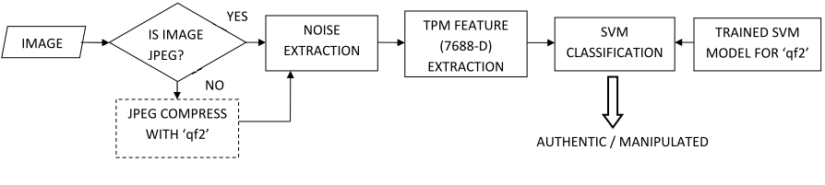

Figure 5.9: The Process Flow of Image Retouching using filters Detection Module

In here it ought to consider the way that identification technique can have the capacity to distinguish that filter is applied whether not considering the way that the kind of filter linear or nonlinear, compressed or uncompressed image. In above chart demonstrate the approach for recognizing the filter. In here utilize the method of when filtering and compressing is applied to a image, the spatial correlation of the pixels in the image gets disturbed. In [19] it is spoken to the compression noise of unfiltered image has low pass characteristics and when filter is applied, relationship of the image pixels is changed. In here it is utilized this conduct of compression noise to assemble a solitary model that can distinguish given picture has applied a filter or not. Here utilize the quantization compression noise demonstrate show by [19] and an adjustment to the characteristic image model to remove compression noise. And furthermore include some adjustment by incorporating the impacts of blocking artifacts due to compression. It is extricated compression noise and afterward demonstrated as a first order spatial ergodic Markov chain [21-24] which has been ended up being a powerful feature. These highlighted features are used to identify whether filter is applied or not. Here for the most part beneath strategies are relied upon to actualize on the general framework.

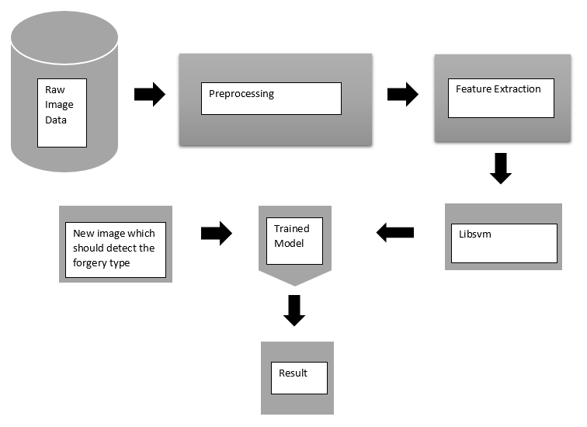

Figure 5.10: The complete design of the Image Retouching using filters Detection Module

Take the normal image at that point change over into vectorized form of 8*8 block. Then process each block separately. In here consider each block in dct domain. Then we need to take the quantization noise. Then this quantization noise is represented as a zero mean multivariate Gaussian. Here we utilize this representation for building a image model to easily get the compression noise. It additionally utilize the Markov Random Field Modeling and Huber function to fabricate the image model. Then we apply the Bayesian MAP estimation for extricating the compression noise from earlier and noise model. By utilizing this estimation we can figure the noise evacuated form of image. Using this compression noise removed image we can compute the noise from subtracting from the primary picture which has connected the compression and filter. Then the removed noise represented as first order ergodic spatial Markove chain. Here the highlights that we use to describe this noise is progress likelihood matrix. Here we can separate 7688 highlights for each picture and this remaining parts unaltered the regardless of the span of the image. Then these highlights are utilized to prepare a SVM display and group a test picture as filtered or unfiltered utilizing a prepared model. Here we utilize image dataset of 3000 NCID pictures and UNID pictures and crude picture of Dresden picture database. Here we apply straight and non-direct channels for picture dataset and some are remains unchanged. Here we packed UCID picture with a specific quality factor. Here we likewise utilize the Libsvm for the classification likewise we need to consider the piece measure when we preprocess the pictures for preparing.

Figure 5.11: Flow chart for the Image Filtering Detection Module

In the first step it is divided the original image into 8*8 block as non-overlapping blocks. Here it denotes I is the input image. Then takes the vectorized 8*8 block image as the Z in the spatial domain. Then takes Y as the vectorized form of the corresponding block in DCT domain. Here all the processing are done as separate single blocks. Then calculate the compression noise for a non-overlapping block as

(5.15)

$$e_{z}=Z- Z_{q} where Z_{q} is the quantized block$$

D = 64 is the number of dimensions of the multivariate Gaussian.

Then use a natural language image model based on the Markov Random Field (MRF). It represent a local structure of image using conditional probability distribution where image pixels values depend only on its neighborhood.

Then take a joint distribution given by Gibbs measure as,

(5.16)

$$p\left(Z\right)= \frac{1}{β }\exp\left(-λ \sum_{c∈C}{ρT(d_{c}^{t}Z}\right)$$

$β$ is a normalized constant.

$c$ are local groups called cliques C is the set of all such cliques depending on the neighborhood structure of the Hubber Markove Random Field(HMRF).

$ρT(.)$ is the Hubber function.

$d_{c}^{t}$ extract differences between a pixel and its neighbors such that the prior model generates to,

(5.17)

$$p\left(Z\right)= \frac{1}{β} exp⁡\left( - λ \sum_{m=0}^{M-1}{\sum_{n∈Nm}{ρT(Z\left[n\right]-Z\left[m\right])}}\right)$$

Where,

$Nm$ is the index set of neighbors for the

$m^{th}$ pixel, and M is the number of pixels in the block.

In the next step apply a denoising algorithm which uses a modified version of the above model. Then extracts the features and classify.

Then it is used a modified version of the above given equation (5.17) for quantization noise extraction. Then modified version of the Hubber function is derived as bellow.

(5.18)

$$ρT\left(u\right)= \left\{\begin{aligned}wu^{2} \left|u\right|≤T \\ w\left(T^{2}+2T\left(\left|u\right|-T\right)\right), \left|u\right|>T\end{aligned}\right.$$

$$w= \left\{\begin{aligned}1 ∀ Z\left(u\right):u∈S, \\ γ otherwise\end{aligned}\right.$$

Here T the threshold set. Parameters

$γ$ and T are empirically determined. S is the set of pixels which belong to the border pixels in each 8 * 8 block. Then it is used the Bayesian MAP estimation for extracting the compression noise from the prior and the noise model. The maximum a posteriori (MAP) criterion is,

(5.19)

$\hat{Z}$ = $\begin{aligned}argmax \\ z\end{aligned} p(Z|Z q)$ = $\begin{aligned}argmax \\ z\end{aligned} p(Z)p(Z q|Z)$

Here Z is the final estimate for the block after removing the compression noise. Though

$Z q$ is a deterministic function of Z, the $p(Z q|Z$) term in the above equation is considered as a Gaussian random variable with mean Z and auto covariance $K_{eZ }$. After substituting we can get,

$\hat{Z}$ = $\begin{aligned}argmax \\ z\end{aligned}$ {$\frac{1}{β}exp\left(-λ\sum_{m=0}^{M-1}{\sum_{n∈N_{m}}{ρT}}\left(Z\left[n\right]-Z\left[m\right]\right)\right)\left(\frac{1}{{\left(2π\right)}^{D/2}{\left|K_{ez}\right|}^{1/2}}exp\left(\frac{-1}{2}e\begin{aligned}T \\ Z\end{aligned}K_{e_{z}}\right)\right)$}

(5.20)

Here the argument of exp (.) in eq(5.20) is minimized using the gradient descent algorithm. Then it is generate the noised image I by combining all the resulting denoised non overlapping blocks. Here compression noise Nc for the image is then obtained as $N_{c}=I- I^{^}$

Then it is calculate the transition probability matrix for the feature extraction. Noise extracted from a JPEG compressed image is modeled as a first order ergodic spatial Markov chain in below way.

(5.21)

$$p(X_{t+1}=x|X=x_{1},X_{2}= x_{2},…,X_{t}=x_{t})$$

Where $X_{t+1}$ is the present state and $x_{1}, x_{2},..,x_{t}$ are the previous states. Here we use the transition probability matrix (TPM) for characterize the noise.

Design should be considered with Dataset design.

## 5.4 Summary

The chapter 5 describes the analysis and the design of all four modules with illustrations as well as the necessary steps of algorithms. It gives a comprehensive understanding about how the project work is carried out under different modules.

Chapter 6

# 6. Implementation

## 6.1 Introduction

This chapter describes the implementation of proposed solution under four modules that are Image Cloning Detection, Image Resampling Detection, Image Splicing Detection and Image Retouching with filters Detection. The details on how the previously mentioned technologies are used to implement the identified solution is included here. All the significant and important implementation steps are shown by pseudo codes. Furthermore the implementation codes are attached under Appendix B.

## 6.2 Implementation

The implementation process of four modules are described below under sub chapters.

### 6.2.1 Image Cloning Detection Module

**Segmentation** → it is done using the scikit image library. This will generate a mask of segments with specific integer value for each segment. With the x,y values of a SIFT feature and this mask we can decide to which segment the key point is falling into.

**Feature segmentation** → the obtained SIFT features are segmented into different patches obtained through SLIC algorithm, based on the position of the key point.

The clustered key points are held by a dictionary of patch integer value as the key and an array of “KeyDes” class as the value. That mean we have added all the key points found in a particular patch under the patch number in the dictionary. The definition of the class is as shown below,

**class** KeyDes:

**def** __init__(self, keypoint=**None**, descriptor=**None**):

*"""this act as the constructor"""*

self.keypoint = keypoint

self.descriptor = descriptor

now this obtained dictionary of classified key points is used to match between the key points and hence get the matched clusters.

**Patch Matching** → this is the most computationally intensive and longest process in the forgery detection. Because here we iterate the classified key point dictionary itself and on it again, without revisiting the checked key again. All together this will give (nxn – n!) number of iterations if the size of the dictionary is n.

Now this iteration means that we irate through the patches that we have identified with key points. But we need to iterate through the key points of each patch to match with other. For this we iterate the added key points in the dictionary inside the iteration of dictionary key values that is already explained above. Now this will multiply the above iterations by a factor of ( Σ aixbj ) where i is the number of key points in the ith path and j is that in the jth patch.

New within each of this iteration euclidean distance is calculated between two patches. And in case the distance is not within the threshold then we keep track of the distance measure we obtained and the pair of key points participated as we need to do HOG calculation later in case we did not get any matches in the above mentioned process.

Now if we found the matches under the threshold then we stop the process form here and visualize the tampered region.

**Suspect patch detection** →In case we do not get any matches in the process up to now then based on the assumption that there can be some possible tampering between the areas where the key points lies that gave the least distance measurement, they are checked for copy move forgery.

Here what we do is taking HOG descriptor of rounded off area of one suspect patch and then same the same size area form the other patch. Now as we apply HOG algorithm we’ll receive descriptor of same size and these are compared with each other to check whether they lie within our threshold defined. If they are matching then those two patches are selected as forged areas.

### 6.2.2 Image Resampling Detection Module

The implementation of the Image Resampling Detection module was divide into two main parts as follows.

* Generation of the periodicity map
* Extracting features from the periodicity map and developing the Support Vector Machine for Classification

The implementation was carried out using the Matlab IDE.

#### 6.2.2.1 Generation of the periodicity map

As mentioned above in the previous chapter, resampling introduces periodic correlations between pixels. These should be differentiated from the natural correlations exist between neighboring pixels to determine whether an image is resampled or not. For that Expectation Maximization (EM) Algorithm was used. Following pseudocode was used for the implementation of the EM algorithm.

/* Initialize values*/

choose a random $\vec{α}$

choose N and $σ_{0}$

set *p0* to the reciprocal of the range of the signal $\vec{y}$

set h to be a binomial low-pass filter of size ($N_{h }$) x ($N_{h }$).

n = 0

**repeat**

**for** each sample *i*

Do the Expectation Step

Calculate the residual error

**end**

W = 0

**repeat**

**for** each sample *i*

Do the Maximization Step

Calculate new weights

**end**

128 x 128 window size of an image was used for simplicity and as tampering in small blocks can be idenfied better. So as the first step of the image resampling the image was cropped. Then we had to select values for $\vec{α}$ for the first iteration of the E step and for σ of the Gaussian Distribution. The initial values were assigned as follows. These values were determined by observing the results generated by the periodicity map.

% initialize parameters

alpha = rand(1,wlen^2-1)';

alpha = alpha./sum(alpha(:)); % normalize weights

sigma = 0.75;

Once these values were determined implementation of the Expectation Maximization algorithm was done using the following code segments.

% E-step

R = yt - Yt*alpha; % find residuals

P = 1/(sigma*sqrt(2*pi)) * exp(-R.^2/(2*sigma.^2)); % find probabilities

w = P./(P+p0);

% M-step

sigma = sqrt( sum(w.*R.^2)/sum(w) );

alpha = (Yt'*diag(w)*Yt) \ Yt'*diag(w)*yt;

if(max(abs(prev-alpha))<EPSILON)

break;

end

The periodicity map was generated by the following code lines.

Pmap = 1/(sigma*sqrt(2*pi)) * exp(-(y-Y*alpha).^2/(2*sigma.^2));

Pmap = reshape(Pmap,[height-2*N width-2*N]);

The output from the periodicity map for a non-resampled image and a resampled image can be shown as follows.

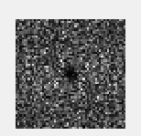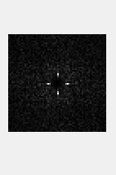

(a) (b)

Figure 6.1 The periodicity map of a non-resampled image (a) and resampled image (b)

The periodic patterns that can be seen in the resampled image was generated due to correlations introduced during resampling. So it can be used to indicate resampling.

Then this periodicity map is Fast Fourier transformed to suppress natural peaks available in an image. It was done in the following manner using the inbuilt functions available in Matlab.

function y = fft2c(x)

y = fftshift(fft2(fftshift(x)));

#### 6.2.2.2 Extracting features from the periodicity map and developing the Support Vector Machine for Classification

After the generation of the Periodicity Map, the above mentioned features had to be extracted from it. The following code segments were used for it.

N = 4;

sum = 0 ;

[ b, ix ] = sort( pmapRow(:), 'descend' );

[ rr, cc ] = ind2sub( size( pmapRow), ix(1:N) );

for ii = 1 : N

disp( pmapRow( rr(ii), cc(ii) ) )

sum = sum + (pmapRow( rr(ii), cc(ii)));

end

f1 = sqrt(sum);

disp(sum);

end

f1 = sqrt(sum);

disp(f1);

N2 = 4;

sum2 = 0 ;

[ b, ix ] = sort(abs(fmapRow(:)), 'descend' );

[ rr, cc ] = ind2sub( size( fmapRow), ix(1:N) );

for ii = 1 : N2

disp( fmapRow( rr(ii), cc(ii) ) )

sum2 = sum2 + (fmapRow( rr(ii), cc(ii)));

end

f2 = sqrt(sum);

disp(f2);

for ii = 1 : N

disp(R( rr(ii), cc(ii) ) )

f3 = f3 + (R( rr(ii), cc(ii)));

end

f3 = f3/100;

disp(f3);

for ii = 1 : N

disp(R( rr(ii), cc(ii) ) )

f4 = 10000 (R( rr(ii), cc(ii)));

end

f4 = f4/100;

disp(f4);

These extracted features were saved in three .csv files as Test Data, Training Data, and Class Labels. Then the model was trained using and tested for test data. Some code segments used to train the model of the SVM was trained as follows.

load trainData2.csv

load featues.csv

load trainLabelsDataComplete.csv

grp2idx(trainLabelsDataComplete);

x = featues (1:42,:);

y = trainLabelsDataComplete(1:42,:);

rand_num = randperm(42);

X_train = x(rand_num(1:34),:);

y_train = y(rand_num(1:34),:);

X_test = x(rand_num(35:end),:);

y_test = y(rand_num(35:end),:);

c = cvpartition(y_train,'k',5);

opts = statset('display','iter');

fun = @(train_data,train_labels,test_data,test_labels)...

sum(predict(fitcsvm(train_data,train_labels,'KernelFunction','rbf'),test_data) ~= test_labels)

[fs,history] = sequentialfs(fun,X_train,y_train,'cv',c,'options',opts,'nfeatures',2);

X_train_W_best_features = X_train(:,fs);

%Mdl = fitcsvm(X_train_W_best_features,y_train);

Mdl = fitcsvm(X_train_W_best_features,y_train,'Standardize',true,'KernelFunction','RBF',...

'KernelScale','auto');

CVSVMModel = crossval(Mdl);

classLoss = kfoldLoss(CVSVMModel);

sv = Mdl.SupportVectors;

figure

gscatter(X_train_W_best_features(:,1),X_train_W_best_features(:,2),y_train)

hold on

plot(sv(:,1),sv(:,2),'ko','MarkerSize',10)

legend('1','0','Support Vector')

hold off

X_test_w_best_feature =X_test(:,fs);

accuracy = sum(predict(Mdl,X_test_w_best_feature)== y_test)/length(y_test)*100;

### 6.2.3 Image Splicing Detection Module

Image Splicing Detection was carried out under 3 different approaches. They are:

* Noise Pattern Analysis
* Colour Filter Array Interpolation Analysis

#### 6.2.3.1 Noise Pattern Analysis

Noise Pattern Analysis Module was implemented with Matlab hence the matrix handling and other required processing were easier with it. High Resolution, Not skewed images that are not undergone with image resampling were needed for the testing purposes. Therefore a suitable dataset was developed by combining well-known datasets such as Dresden [1] and CASIA [2]. Different functions and scripts were developed for noise pattern estimation. All the required code segments are attached with Appendix B. The Pseudo code for the algorithm is shown at the end of this chapter with necessary code segments.

Once we select the image, it will be sent through “CleanUpImage” function to cover many extreme cases that appear in real world datasets. The input images could be with more than 3 channels and occasionally uint16 images. Therefore this function converts such images into 3 channel uint8 images.

Once the image is cleaned, the noise map should be generated. In order to do that image should be separated into non merging blocks. The BlockSize was determined as 32 after a series of experiments. The noise level analysis was done inside the GetNoiseMap function.

As the first step of analysis, the image is converted into YCbCr model. Then its Y component, as known as Luma component is separated for further processing. Discrete Wavelet Transformation is applied on top of the Y component in order to denoise the image. For that Daubechies wavelet with level 8 decomposition was selected after comparing and contrasting with other wavelet families available. As a result of the wavelet transformation, we get four types of coefficient matrices such as:

* cA – Approximation Coefficient Matrix
* cH – Horizontal Detail Coefficient Matrix
* cV – Vertical Detail Coefficient Matrix
* cD – Diagonal Detail Coefficient Matrix

Out of the above, cD which returns as a double array, is selected for further processing hence it has image properties stored with itself. Separating the cD into blocks of 32 is the task lined up next. But the original cD array might not be a multiple of 32. Therefore cD has to be rounded off before merging it into blocks. After the rounding off process, a 3 dimensional matrix is created and filled with zeros to fill the blocks that are separated from the image.

For loop is used to store each and every block inside the 3 dimensional matrix. The for loop increment differs according to the selected BlockSize.

After the blocks are separated, the noise of each block will be estimated by further calculations as mentioned in [12]. The estimated noise levels are stored in a 2x2 matrix.

The noise map is plotted as the final output.

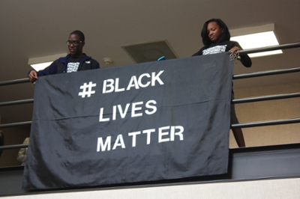

**a**

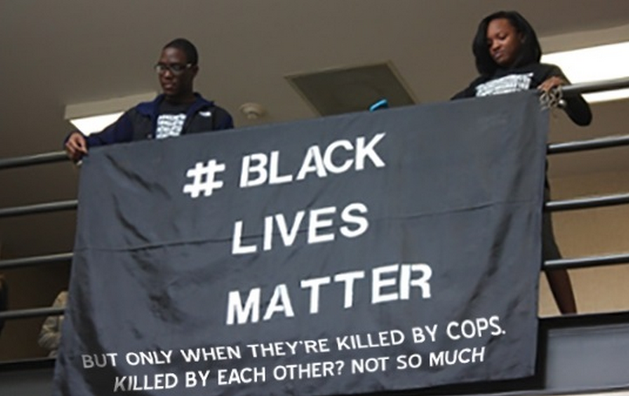

**b**

Figure 6.2: The Authentic Image (a) and the respective Tampered Image (b)

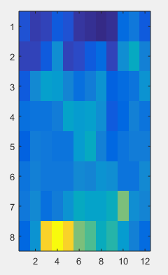

Figure 6.3: The respective Noise map with the localization of the tampered area.

**Pseudo Code**

Algorithm: Noise Pattern Analysis

**Input**: High resolution tampered image that hasn’t under gone any resampling

**Output**: Noise map of the image with localization of tampered area

**Process**:

* **CleanUp Image**

If the image is not in 3 channel uint8 format, convert it into 3 channel image.

if numel(size(im))>3

im=im(:,:,:,1,1,1,1);

end

dots=strfind(filename,'.');

extension=filename(dots(end):end);

if strcmpi(extension,'.gif') && size(im,3)<3

[im_gif,gif_map] =imread(filename);

im_gif=im_gif(:,:,:,1);

im=uint8(ind2rgb(im_gif,gif_map)*255);

end

if size(im,3)<3

im(:,:,2)=im(:,:,1);

im(:,:,3)=im(:,:,1);

end

* **Convert the image into YCbCr model and extract the ‘Y’ component**

YCbCr=double(rgb2ycbcr(im));

Y=YCbCr(:,:,1);

* **Apply Single level discrete 2-D wavelet transform**

[cA1,cH,cV,cD] = dwt2(Y,'db8');

* **Tiling sub-band HH1 with non-overlapping blocks**

cD=cD(1:floor(size(cD,1)/BlockSize)*BlockSize,1:floor(size(cD,2)/BlockSize)*BlockSize);

Block=zeros(floor(size(cD,1)/BlockSize),floor(size(cD,2)/BlockSize),BlockSize.^2);

* **Fill the blocks with image tiles into a 3 dimensional matrix**

for ii=1:BlockSize:size(cD,1)-1

for jj=1:BlockSize:size(cD,2)-1

blockElements=cD(ii:ii+BlockSize-1,jj:jj+BlockSize-1);

Block((ii-1)/BlockSize+1,(jj-1)/BlockSize+1,:)=reshape(blockElements,[1 1 numel(blockElements)]);

end

end

* **Noise Variance Estimation**

s=median(abs(Block),3)./0.6745;

Map=s;

#### 6.2.3.2 Colour Filter Array Interpolation Analysis

Colour Filter Array (CFA) Analysis Module was also implemented with Matlab. Finding suitable dataset for testing and evaluation purposes was one of the most difficult tasks found during the implementation. Images that are taken from different cameras were needed for the testing purposes. Therefore a suitable dataset was developed with the use of Benchmark Dataset [3]. All the required code segments are attached with Appendix B. The Pseudo code for the algorithm is shown at the end of this chapter with necessary code segments.

Image Interpolation can be taken as the process of estimating values of certain pixels with the aid of its neighboring pixel locations. The images come from digital cameras show demosaicing artifacts on each and every blocks with respect to CFA elements specially when there are no further processing. In this approach, the demosaicing artifacts are studied in local level which leads to image forgery detection.

The algorithm is mostly based on Bayes’ Theorem and related statistical methods as described under the Analysis and Design chapter. Once an image is submitted its green colour component is chosen for the prediction error calculation. The prediction error for both interpolated and acquired scenarios are calculated and their differences are extracted. The Prediction error value is always higher in Acquired scenario whereas Interpolated scenario tends to give a value closer to zero. As the next step, the image is separated into smaller size blocks and calculate the feature L according to the equation (5.13). With the use of this likelihood value, the differences between two variances can be identified which finally leads to the forged area detection. Forgery map is developed with the use of the EM algorithm and the Bayes’ theorem.

The figure 6.4 and 6.5 shows the output received from the algorithm when Nb value as known as feature dimension is set to 2. In addition to the above shown results, the probability map and the histogram map could be retrieved for different Nb values. For the testing purposes this algorithm outputs Nb = 8 and Nb = 2 histogram map and the probability map. After a series of experiments it was decided that the Nb = 2 is the ideal value.

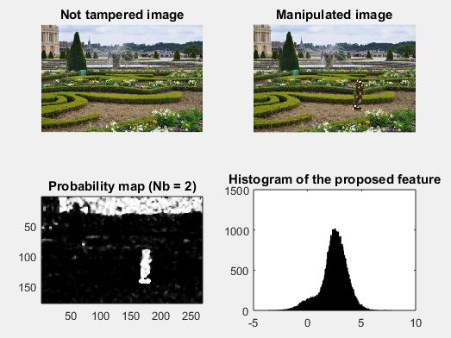

Figure 6.4: The Authentic Image, Tampered Image, Probability Map and the Histogram of the proposed feature.

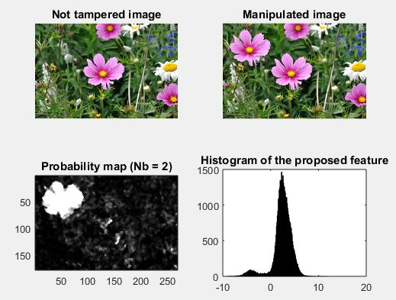

Figure 6.5: The Authentic Image, Tampered Image, Probability Map and the Histogram of the proposed feature.

**Pseudo Code**

Algorithm: CFA Interpolation Analysis

**Input**: High resolution tampered image – tampered area should be captured from a different camera other than the camera used to capture the authentic image.

**Output**: Probability map of the image with localization of tampered area and the Histogram Map for the feature calculated

**Assumption** : The 2x2 Bayer pattern for Green colour is known.

**Process**:

* **Stating Feature Dimension, Number of blocks to cumulate and the Bayer pattern for the Green colour.**

The system output results for two feature dimensions. The values have been selected after a series of experiments.

% dimensione of statistics

Nb = [2, 8];

% number of cumulated bloks

Ns = 1;

% Pattern of CFA on green channel

bayer = [0, 1;

1, 0];

* **Input Images**

The system is capable to have four inputs at a time. Two pairs of Tampered Images and their respective Authentic Images.

for i = 1:2:3

im_true = imread(filename{i});

im = imread(filename{i+1});

for j = 1:2

* **Green Channel Extracting**

im = image(:,:,2);

[h, w] = size(im);

dim = [h, w];

* **Prediction Error Calculation**

The prediction error I further filtered for the denoising purposes.

function [pred_error] = prediction(im)

% predictor with a bilinear kernel

Hpred = [ 0, 0.25, 0;

0.25, -1, 0.25;

0, 0.25, 0 ];

pred_error = imfilter(double(im),double(Hpred),'replicate');

return

* **Local Variance for both Acquired and Interpolated pixels**

var_map = getVarianceMap(pred_error, Bayer, dim);

function [var_map] = getVarianceMap(im,Bayer,dim)

% extend pattern over all image

pattern = kron(ones(dim(1)/2,dim(2)/2), Bayer);

% separate acquired and interpolate pixels for a 7x7 window

mask = [1, 0, 1, 0, 1, 0, 1;

0, 1, 0, 1, 0, 1, 0;

1, 0, 1, 0, 1, 0, 1;

0, 1, 0, 1, 0, 1, 0;

1, 0, 1, 0, 1, 0, 1;

0, 1, 0, 1, 0, 1, 0;

1, 0, 1, 0, 1, 0, 1];

% gaussian window fo mean and variance

window = gaussian_window().*mask;

mc = sum(sum(window));

vc = 1 - (sum(sum((window.^2))));

window_mean = window./mc;

% local variance of acquired pixels

acquired = im.*(pattern);

mean_map_acquired = imfilter(acquired,window_mean,'replicate').*pattern;

sqmean_map_acquired = imfilter(acquired.^2,window_mean,'replicate').*pattern;

var_map_acquired = (sqmean_map_acquired - (mean_map_acquired.^2))/vc;

% local variance of interpolated pixels

interpolated = im.*(1-pattern);

mean_map_interpolated = imfilter(interpolated,window_mean,'replicate').*(1-pattern);

sqmean_map_interpolated = imfilter(interpolated.^2,window_mean,'replicate').*(1-pattern);

var_map_interpolated = (sqmean_map_interpolated - (mean_map_interpolated.^2))/vc;

var_map = var_map_acquired + var_map_interpolated;

return

* **Proposed Feature Calculation**

stat = getFeature(var_map, Bayer, Nb);

function [statistics] = getFeature(map,Bayer,Nb)

% Proposed feature to localize CFA artifacts

pattern = kron(ones(Nb/2,Nb/2),Bayer);

func = @(sigma) (prod(sigma(logical(pattern)))/(prod(sigma(not(logical(pattern))))));

statistics = blkproc(map,[Nb Nb],func);

statistics(isnan(statistics))=1;

statistics(isinf(statistics))=0;

return

* GMM Parameter Estimation

[mu, sigma] = MoGEstimationZM(stat);

function [mu,sigma,mix_perc] = MoGEstimationZM (statistics)

% Expectation Maximization Algorithm with Zero-Mean forced first component

% E/M algorithm parameters inizialization

tol = 1e-3;

max_iter = 500;

% NaN and Inf management

statistics(isnan(statistics)) = 1;

statistics(statistics<0)=0;

data = log(statistics(:));

data = data(not(isinf(data)|isnan(data)));

% E/M algorithm

[alpha, v1, mu2, v2] = EMGaussianZM(data, tol , max_iter);

% Estimated model parameters

mu= [mu2 ; 0];

sigma = sqrt([v2; v1]);

mix_perc = [1-alpha;alpha];

return

* **Likelihood Map Generation**

loglikelihood_map = loglikelihood(stat, mu, sigma);

function [L] = loglikelihood(statistics, mu, sigma)

% Loglikelihood map

% allowable values for logarithm

min = 1e-320;

max = 1e304;

statistics(isnan(statistics))=1;

statistics(isinf(statistics))=max;

statistics(statistics == 0) = min;

statistics(statistics<0)=0;

mu1=mu(2);

mu2=mu(1);

sigma1=sigma(2);

sigma2=sigma(1);

% log-likelihood

L = log(sigma1) - log(sigma2) ...

-0.5.*((((log(statistics) - mu2).^2)/sigma2^2) - ...

(((log(statistics) - mu1).^2)/sigma1^2));

return

* **Filtered and Cumulated Likelihood map generation**

map = getMap(loglikelihood_map, Ns, Nm);

function [map] = getMap(L, Ns, Nm)

% Cumulated and median filtered log-likelihood map

% cumulate blocks

func = @(x) sum(x(:));

log_L_cum = blkproc(L,[Ns Ns],func);

% median filtered log-likelihood

map = medfilt2(log_L_cum,[Nm Nm],'symmetric');

return

* Plot the Results

% plot result

figure

subplot(2,2,1), imshow(im_true), title('Not tampered image');

subplot(2,2,2), imshow(im), title('Manipulated image');

subplot(2,2,3), imagesc(map), colormap('gray'),axis equal, axis([1 w 1 h]), title(['Probability map (Nb = ',num2str(Nb(j)),')']);

subplot(2,2,4), hist(data, n_bins), title('Histogram of the proposed feature');

display('Press any key to continue...')

### 6.2.4 Image Retouching using Filters Detection Module

Here we implement the denoising of image using the Hidden Markov Random Field Modeling. Then we can able to extract the noise by subtracting the denoised image from the first image Then extracted noise is used to determine if the given image is filtered or not. Here we take uncompressed image data set, Never compressed and raw image data set extracted from camera to do the training and testing stages. Also here we used the libsvm for svm classification.

Here we have to consider separately noise separation and feature extraction from image.

Image denoising code sample.

function [denoisedimage,noise,error]=noise_finalone(image,quality,weight,maxiter)

if ~exist('weight','var')

weight = 1;

end

if ~exist('maxiter','var')

maxiter = 50;

end

%patchsize (DCT block size)

step = 8;

%Get the image

readcompressimage=double(image);

%initialize gamma as in paper

gamma = 1;

%Block size as givenby patchsize

blockX = step;blockY = step;

%Quantization table

Q50=[ 16 11 10 16 24 40 51 61;

12 12 14 19 26 58 60 55;

14 13 16 24 40 57 69 56;

14 17 22 29 51 87 80 62;

18 22 37 56 68 109 103 77;

24 35 55 64 81 104 113 92;

49 64 78 87 103 121 120 101;

72 92 95 98 112 100 103 99];

%Linear operation as done in JPEG compression

if quality > 50

Q = round(Q50.*(ones(8)*((100-quality)/50)));

elseif quality < 50

Q = round(Q50.*(ones(8)*(50/quality)));

elseif quality == 50

Q = Q50;

end

Q=double(Q);

% if step==16

% Q = repmat(Q,2,2);

% Create DCT Matrix

H = dct(eye(step));

% kronecker prod of DCT matrix

G =kron(H,H);

% getting noise covariance matrix

q=reshape(Q,[1 64]);

%determining variance as in the paper

varfreq = ((gamma.*q).^2)/12;

B = repmat(varfreq,[1 blockX*blockY/64]);

Key = double(diag(B));

%The noise covariance matrix

Kez = G'*Key*G;

kezinv=inv(Kez);

% Block by block denoising

for i=1:step:size(readcompressimage,1)

for j=1:step:size(readcompressimage,2)

y = readcompressimage(i:i+step-1,j:j+step-1);

% zq=reshape(y,[step*step 1]);

xblock = padarray(y,[1 1],'replicate');

denoisedimage(i:i+step-1,j:j+step-1)= grad_finalone(y(:),xblock,kezinv,weight,maxiter);

% k=k+1;

end

end

%Extract noise from denoised image

noise = double(denoisedimage) - double(readcompressimage(1:size(denoisedimage,1),1:size(denoisedimage,2)));

noise = reshape(noise,[1 size(noise,1)*size(noise,2)]);

%truncating denoised image

denoisedimage(denoisedimage<0)=0;denoisedimage(denoisedimage>255)=255;

end

Code for extract the features

function output = extract_TPM(input,choice,range)

% Difference array calculation

% Just two or four directions for certain applications might be optimal

dir{1} = input(2:end,:) - input(1:end-1,:); %Vertical bottom to top direction

dir{2} = input(1:end-1,:) - input(2:end,:); %Vertical top to bottom

dir{3} = input(:,2:end) - input(:,1:end-1); %Horizontal right to left

dir{4} = input(:,1:end-1) - input(:,2:end); %Horizontal left to right

dir{5} = input(2:end,2:end) - input(1:end-1,1:end-1); %Major diagonal bottom to top

dir{6} = input(1:end-1,2:end) - input(2:end,1:end-1); %Minor diagonal top to bottom

dir{7} = input(2:end,1:end-1) - input(1:end-1,2:end); %Minor diagonal bottom to top

dir{8} = input(1:end-1,1:end-1) - input(2:end,2:end); %Major diagonal top to bottom

if strcmp(choice,'sign')

val = 9;

elseif strcmp(choice,'truncate')

val = (2*range+1)^2;

end

%TPM calculation

TPM = cell(1,8)

for i = 1 : 8

D = dir{i};

if strcmp(choice,'sign')

D=sign(D);

D=D+2;

elseif strcmp(choice,'truncate')

D=round(D);

D(D>range)=range;D(D<-range)=-range;

D=D+range+1;

end

%TPM calculates along the same direction that the gradient is

%calculated (Can be modified if needed)

TPM{i} = reshape(transprobestimate(D,choice,range,i),[1 val]);

end

output = [TPM{1},TPM{2},TPM{3},TPM{4},TPM{5},TPM{8},TPM{6},TPM{7}];

clear TPM;

end

function TPM = transprobestimate(input,choice,range,direction)

%function output = transprobestimate(input,choice,range,direction)

if strcmp(choice,'sign')

t=zeros(3,3);

elseif strcmp(choice,'truncate')

t=zeros(range*2+1,range*2+1);

end

switch direction

case 1

%Vertical bottom to top direction

t1=sparse(input(2:end,1:end),input(1:end-1,1:end),1);

case 2

%Vertical top to bottom direction

t1=sparse(input(1:end-1,1:end),input(2:end,1:end),1);

case 3

%Horizontal right to left direction

t1=sparse(input(1:end,2:end),input(1:end,1:end-1),1);

case 4

%Horizontal left to right direction

t1=sparse(input(1:end,1:end-1),input(1:end,2:end),1);

case 5

%Major diagonal bottom to top direction

t1=sparse(input(2:end,2:end),input(1:end-1,1:end-1),1);

case 6

%Minor diagonal top to bottom direction

t1=sparse(input(1:end-1,2:end),input(2:end,1:end-1),1);

case 7

%Minor diagonal bottom to top direction

t1=sparse(input(2:end,1:end-1),input(1:end-1,2:end),1);

case 8

%Major diagonal top to bottom direction

t1=sparse(input(1:end-1,1:end-1),input(2:end,2:end),1);

otherwise

error('Wrong Argument direction');

end

t1=full(t1);

t(1:size(t1,1),1:size(t1,2))=t1;

for i=1:size(t,1)

e(i,:) = t(i,:) ./ sum(t(i,:));

end

for i=1:size(e,1)

for j=1:size(e,2)

if (isnan(e(i,j)))

e(i,j)=0;

end

end

end

TPM=e;

end

Gradient calculation

% gradient calculation

function [xopt,err] = grad_finalone(zq,xblock,kezinv,weight,maxiter)

zq=double(zq);

z = zq;

% termination tolerance

tol = 1e-3;

% Initial step size for gradient descent

alpha = 0.05;

%Initial data vector

x = z;

%Initializing error vector

err=zeros(1,maxiter);

niter=1;

while (niter <= maxiter)

% calculate gradient:

g = grad(xblock,z,zq,kezinv,weight);

temp = z;

% Gradient ddescent step

z = z - alpha*g;

%calculate error for tolerance measure

err(1,niter) = mean(abs((abs(z) - abs(temp))));

%upgrade alpha at every step

alpha=alpha-(alpha*0.05);

xnew = z;

%error if value is Inf

if ~isfinite(xnew)

display(['Number of iterations: ' num2str(niter),'aplha is:' num2str(alpha)])

error('x is inf or NaN')

end

x = xnew;

%Update xblock with new values to calculate gradient again

[M,N] = size(xblock);

xblockinter = reshape(xnew,M-2,N-2);

xblock(2:end-1,2:end-1)=xblockinter;

xblock(1,2:end-1)=xblock(2,2:end-1);

xblock(end,2:end-1)=xblock(end,2:end-1);

xblock(:,1)=xblock(:,2);

xblock(:,end)=xblock(:,end-1);

%come out of the loop if tol level reached

if err(1,niter)<=tol

break;

end

%Increment iteration counter

niter = niter + 1;

end

% disp(niter-1);

%Final optimized/denoised block

[M,N] = size(xblock);

xopt = reshape(x,M-2,N-2);

end

function g = grad(xblock,z,zq,kezinv,weight)

% Output -

% g - gradient calculated based on HMRF model and Quantization noise model.

%Lambda governs the degree of smoothing

lambda = 0.08;

%Threshold to define huber function as set in the paper

T = 10;

%Initializations

[M,N] = size(xblock);

xblock = double(xblock);

pho=zeros(3,3);%r=0;

phoo = zeros(5,5);

r=xblock(M-2,N-2);

%HMRF calculation

for l = 2:M-1

for k = 2:N-1

currentpx = xblock(l,k);

for i = 1:3

for j=1:3

u = currentpx - xblock(l+i-2,k+j-2);

if(abs(u)<=T)

if(l-1==1 || k-1==1 || l-1==8 || k-1==8)

pho(i,j) = weight*(2*u);

else

pho(i,j) = 2*u;

end

elseif((u)>T)

if(l-1==1 || k-1==1 || l-1==8 || k-1==8)

pho(i,j) = weight*2*T;

else

pho(i,j) = 2*T;

end

elseif((u)<-T)

if(l-1==1 || k-1==1 || l-1==8 || k-1==8)

pho(i,j) = -weight*2*T;

else

pho(i,j) = -2*T;

end

end

end

end

phoo(2:4,2:4) = pho;

for i = 2:size(phoo,1)-1

for j=2:size(phoo,2)-1

pho (i-1,j-1) = sum(sum(phoo(i,j) - phoo(i-1:i+1,j-1:j+1)));

end

end

r(l-1,k-1) = sum(sum(pho));

end

end

% 'r' term from HMRF

rr=reshape(r,[size(r,1)*size(r,2) 1]);

diffZ = double(z - zq);

% 's' term from quantization noise model

s = kezinv*diffZ;

%gradient as computed in the paper

g = lambda.*rr + s;

end

Here extracted features are sent to Libsvm and build a model to classify the upcoming images.

Here we preprocess the image dataset. Take the images from UCID images, NCID images and Dresden image database. Together make 3000 authentic image set. Another 1000 random images are not present in the previous NCID images are single compressed with a random factor qf1 2 (30; 80]. This set is called splicing set. Here we generate two classes of images for our experiments from these sets. Unfiltered and Filtered. In experiment a JPEG/TIFF image is forged, enhanced using filter randomly from median, Gaussian, average, laplacian or unsharp filters and saved in JPEG format following a typical forgery pipeline. When given image is uncompressed TIFF format, it is JPEG compressed. Compression noise and TPM features are extracted from 6000(3000 unfiltered and 3000 filtered) images.

Chapter 7

# 7. Evaluation and Results

## 7.1 Introduction

This chapter showcases the results obtained for four modules through the implementations that are proposed. The summarized version of results received through experiments are attached herewith. The Authentic Images, Tampered Images and the relevant intermediate graphs and other maps are shown here. The results appear here lead to the conclusions of this research.

## 7.2 Evaluation and Results

### 7.2.1 Image Cloning Detection Module

The proposed solution is capable of finding multiple forged areas. But the drawback is the high computational intensity with the process.

The approach is giving positive results for basic copy-move cloning done using the selection tool and pasting (tested with gimp). Also it is working with the cloning tool. But the image segment identification need to be having a post-processing step to reduce the false positive results that we get. Also since SIFT are detecting blobs it is required to try for some other feature description to get the features of smooth areas.

### 7.2.2 Image Resampling Detection Module

The system was checked with different resampling ratios and different resampling methods such as Bicubic, Bilinear resampling etc. Different block sizes of an image was tried out and it was found that small block sizes give better results as the resampling in a smaller area can be detected precisely.

Different combinations of features were extracted and used in the training of the SVM and the above mentioned features gave best results according to the experimental setting.

When the performance of this approach based on SVM classifier is compared with kNN classifier [8] this shows better performance when an image is resampled with both low and high resampling ratios. This shows a recall percentage of about 90% and precision rate of 80%.

Following images shows how a resampled image is classified by the SVM classifier.

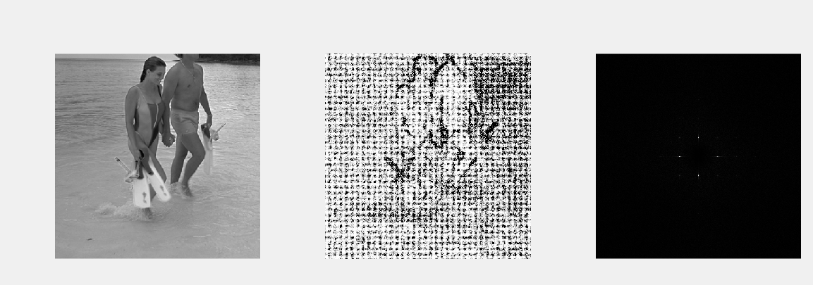

1. (b) (c)

Figure 7.1. Tampered image (a), probability map (b) and periodicity map (c)

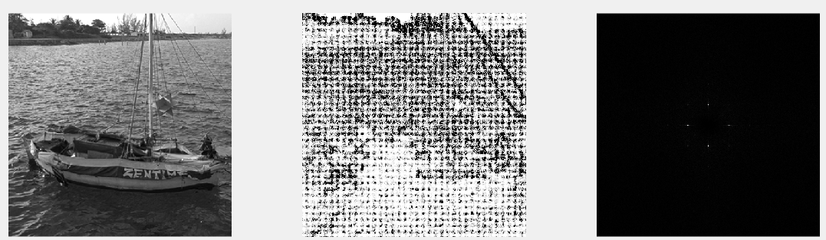

1. (b) (c)

Figure 7.2. Tampered image (a), probability map (b) and periodicity map (c)

It can be seen that the classifier correctly identifies the resampled region in a given image. The false positive rate of this classifier is considerably low and it’s about 4%.

### 7.2.3 Image Splicing Detection Module

#### 7.2.3.1 Noise Pattern Analysis

The results of the evaluation is described here.

The noise pattern analysis algorithm was tested with hundreds of tampered images. The algorithm was able to successfully localize tampered areas in most of the times. Figures from 7.3 to 7.5 shows some of the successful scenarios.

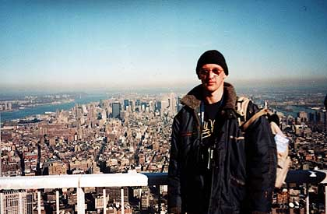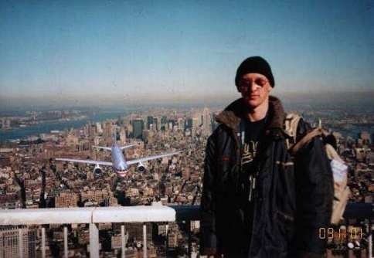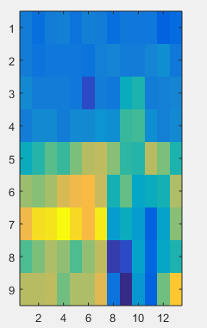

**a**

**b**

**c**

Figure 7.3: Authentic Image (a), Tampered Image (b) and the Noise Map (c)

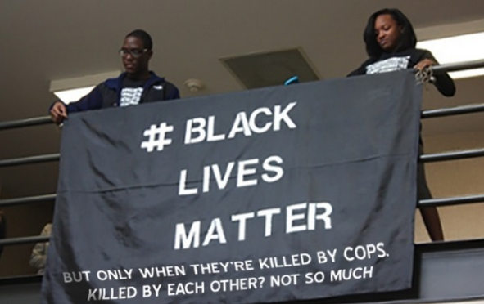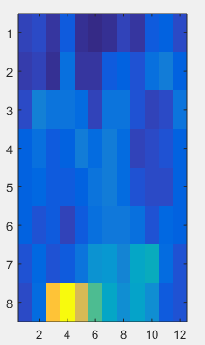

**a**

**b**

**c**

Figure 7.4: Authentic Image (a), Tampered Image (b) and the Noise Map (c)

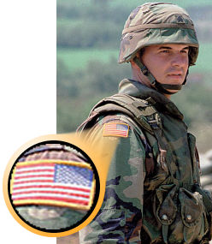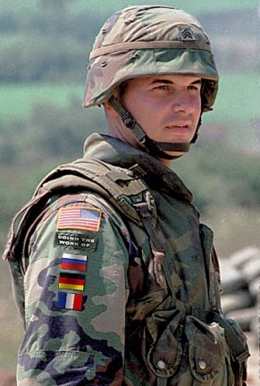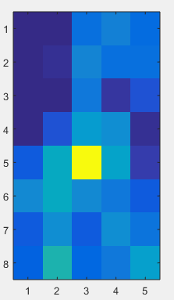

**a**

**b**

**c**

Figure 7.5: Authentic Image (a), Tampered Image (b) and the Noise Map (c)

Furthermore there were some scenarios where the algorithm was unable to detect the exact tampered area. There are many reasons behind those failures. When the images are very low in resolution, when the images are modified with different filters and other processing techniques, when the mages are skewed, etc the algorithm fails to give the correct localization. Some of the failed scenarios are shown under figure 7.6 and 7.7

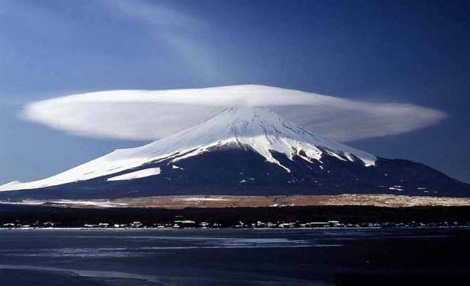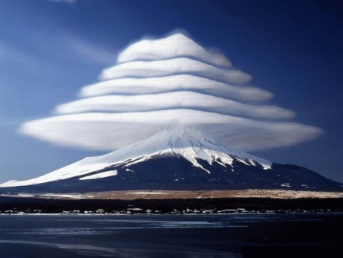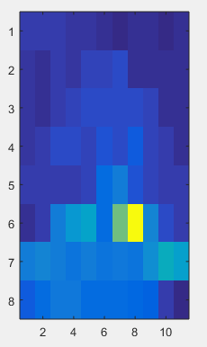

**a**

**b**

**c**

Figure 7.6: Authentic Image (a), Tampered Image (b) and the Noise Map (c) which fails to localize the area correctly.

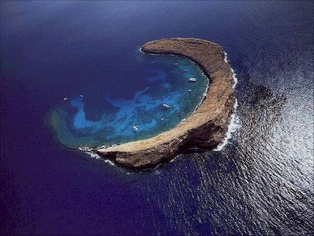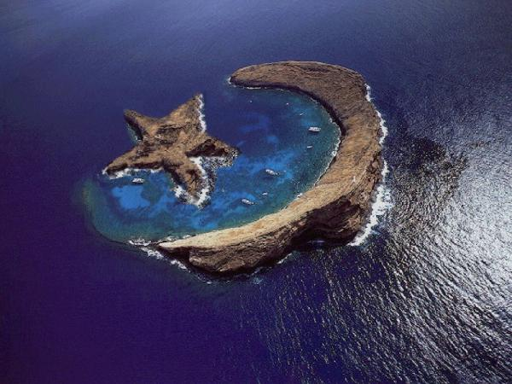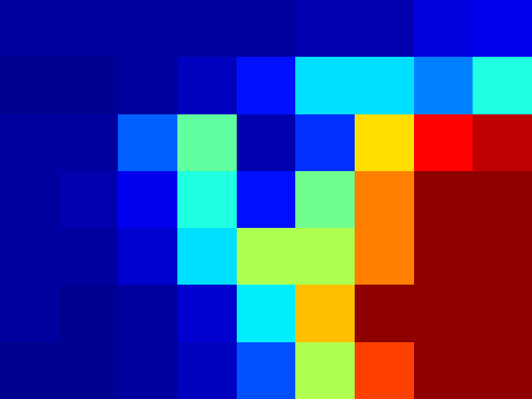

**a**

**b**

**c**

Figure 7.7: Authentic Image (a), Tampered Image (b) and the Noise Map (c) which fails to localize the area correctly.

In this algorithm when we define the tampered area and the authentic area, we consider the least percentage of an area of an image as the tampered one and the larger area as the authentic area as the authentic one after a comparison. But sometimes it is not the intended answer by human. Such scenario is shown under fig ().

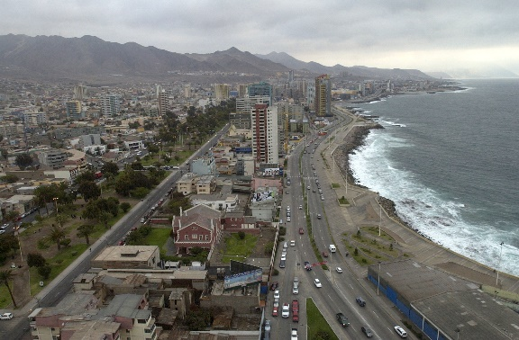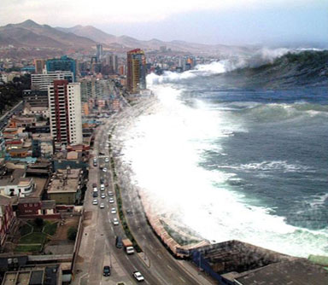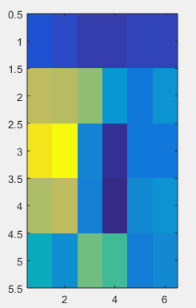

**a**

**b**

**c**

Figure 7.8: Authentic Image (a), Tampered Image (b) and the Noise Map (c) which shows the swapped version of the intended localization.

With all the tested images, I would like to state that the Noise Pattern Analysis algorithm has around 60% accuracy if and only if the input images has the required characteristics.

#### 7.2.3.2 CFA Interpolation Analysis

The results of the algorithm are described below.

The CFA Interpolation Analysis algorithm was tested with different tampered images that are tampered with images taken from different cameras. For the testing purpose, a unique dataset was built using images that are available in Benchmark dataset [[3] https://ieeexplore.ieee.org/document/7780454/

]. But at the moment right now, we have very limited number of images that do not violate the requirements of the algorithm. Therefore the final accuracy level determination was difficult for some extent.

The below figures show some successful scenarios.



Figure 7.9: A Successful Scenario



Figure 7.10: A Successful Scenario

The following figure show an unsuccessful scenario where the both tampered area and the authentic image are taken from the same camera.

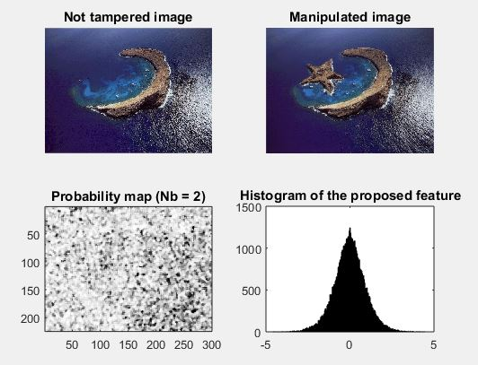

Figure 7.11: An Unsuccessful Scenario

### 7.2.4 Image Retouching with Filters Detection Module

Results of our experiment is given in below. By observing the results we can conclude that the classification accuracy between an unfiltered and a filtered image is on an average above 80% irrespective of the quality factor of the last JPEG compression. In below graph we can see the ROC. When we are taking the consideration of the graph we can see that TPR of 0.8 is achieved for considerable FPR of 0.16 taking into account multiple scenarios together. Here also average of 50 seconds takes for extracting compression noise from one image in a i7 core processor and 6GB RAM using MATLAB. Here compression noise extraction takes more time as each 8*8 block is denoised by gradient descent whose iterations and learning rate are empirically set.



Figure 7.12: ROC graph

By studying previous result we can conclude that average of 80% accuracy can get using this approach without considering the type of filter.

Chapter 8

# 8. Conclusion and Further Work

## 8.1 Introduction

This chapter shows the Conclusion and the further work of the research. It explains the progress of the research from the beginning itself.

## 8.2 Conclusion and Further Work

In this project we have implemented an image forgery detection system comprises of image cloning detection, image resampling detection, image splicing detection and image retouching detection. So far we have referred the available literature covering those areas. There we found the algorithms used, approaches followed so far which are applicable for our project.

Then the initial step carried out by us was analyzing the overall system and each module in the system in terms of input, process and output. The input of each module was identified as an image and the output is the detection result that defines whether an image is forged using a particular forging method or not. To design the process we identified the procedures needed to be followed and algorithms used in the approaches done so far. There we have to customize the available algorithms to suit our requirements and create new algorithms to improve the process in terms of efficiency and accuracy as most of the available methods require high computational cost.

Then we defined the objectives that need to be carried out for the successful completion of the system.

According to the proposed solution and its analysis with design, the implementation was carried out for all four modules. Due to the technical competencies, different technologies were selected for different modules. The main challenges faced by us so far were understanding the available literature in terms of algorithms used, mathematical explanations, processes followed etc. This was the main challenge we faced even in the implementation phase.

After the implementation, we carried out evaluation and testing for separate modules. There we had to search for suitable images as input data. Sometimes we were unable to find relevant datasets from other researchers where we had to implement our own datasets.

Each algorithm implemented for this research may have its own drawbacks and loopholes that are needed to be taken care of. As the future work, it is a must to improve the performance and the accuracy of these algorithms in order to cover a wide range of images. At the moment there are restrictions on input images from which we try to cover the pitfalls in these algorithms. But it would be really helpful if these algorithms are in a state where they are 100% capable to detect forgeries. Once the performance and the accuracy is increased, this system will be a trending one among people because of the rising necessities. Therefore we, Team Auxilium would like to invite anyone who is interested in this area to continue this research to a great height.

Team Auxilium – To the Greater Good

# References